
Local Educational Agency (LEA) Consolidated Application Navigation
LEA Consolidated Application
    
What you will do:

Identify Roles within the LEA Consolidated Application.
Log into the LEA Consolidated Application Website.
Log into the MyGaDOE Portal.
Review the Work Flow.
Review the Navigation Screen.
Complete Application Data.
State Plan Sign-Off.
Add Program(s) into the Application.
Complete Program Data.
Complete Budget Sheets.
Individual Program Sign Off.
Create Amendments.
Edit Amendments.
Perform Queries.
Run Reports.
    
In 1999, Georgia began participating in the Federal Consolidated Application. The signing of No Child Left Behind (NCLB) in 2001 led to some modifications in the application process for FY2002. NCLB reverted back to the Elementary and Secondary Education Act of 1965 (ESEA) in FY10 which led to additional modifications with the inception of the American Recovery and Reinvestment Act of 2009 (ARRA). The current programs that utilize the local educational agency (LEA) Consolidated Application Website as well as several additional programs that have come online in the last few years single-handedly dispense over $1 billion dollars to school systems in Georgia. The purpose of this document and the LEA Consolidated Application overall is to leverage resources across programs to ensure that all children have an opportunity to meet state academic achievement standards. In addition, consolidating the planning and program requirements across all programs participating in the LEA Consolidated Application process eliminates the need for LEAs to submit multiple plans, thus making the application process more efficient for applicants.
Table of Contents
Reviewing Roles 4
Logging into the LEA Consolidated Application Website 5
Logging into the MyGaDOE Portal 5
Reviewing the Work Flow 8
Reviewing the Navigation Screen 9
Completing Application Data 10
Plan Descriptors 10
LEA Implementation Plans 12
Prayer Certification 13
Uploading File Attachments 14
Viewing the Audit Trail within the LEA Consolidated Application 14
Coordination 15
State Plan Sign-Off 17
Consolidated Application Coordinator Sign-Off 17
Superintendent Sign-Off 18
State Plan Approver Sign-Off 21
Adding Program(s) into the Application 22
Information Displayed on the Programs Main Screen 23
Completing Program Data 24
Completing Budget Sheets 44
Individual Program Sign-Off 46
Consolidated Application Coordinator Sign-Off 46
Superintendent Sign-Off 47
State Program Manager Sign-Off 50
State Grants Accounting Sign-Off 51
Creating Amendments 52
Editing Amendments 53
Performing Queries 53
Application Status Query 53
Title I-A School Allocation Query 54
Budget Comparison Query 54
Running Reports 54
Application Summary Report 55
Program Summary Report 55
Budget Summary Report 56
Budget Transferability Report 56
Unbudgeted Funds Report 56
Questions? 56

Reviewing Roles
Five distinct roles are available within the LEA Consolidated Application. They are: LEA Consolidated Application Coordinator, Superintendent, State Consolidated Application Coordinator, State Program Manager, State Plan Approver, and State Grants Accounting.
Role | Access
LEA Consolidated Application Coordinator | Full edit rights to the application. This role is automatically applied to the Consolidated Application Coordinator identified within the MyGaDOE portal.
Superintendent | Read-only access to the application, but has final sign-off for the district.
State Program Manager | Read-only access to the application, but has final sign-off to approve specific program(s) at the State level.
State Consolidated Application Coordinator | Read-only access to the application compiles all approvals and requests for revision at the state level and recommends approval or request for revision.
State Plan Approver | Read-only access to the application, but has final sign-off to approve the State Plan for a district at the State level.
State Grants Accounting | Read-only access to the application, but has final sign-off to approve the budget at the State level.
Logging into the LEA Consolidated Application Website
Within a web browser, logon to the following site:
LEA Consolidated Application
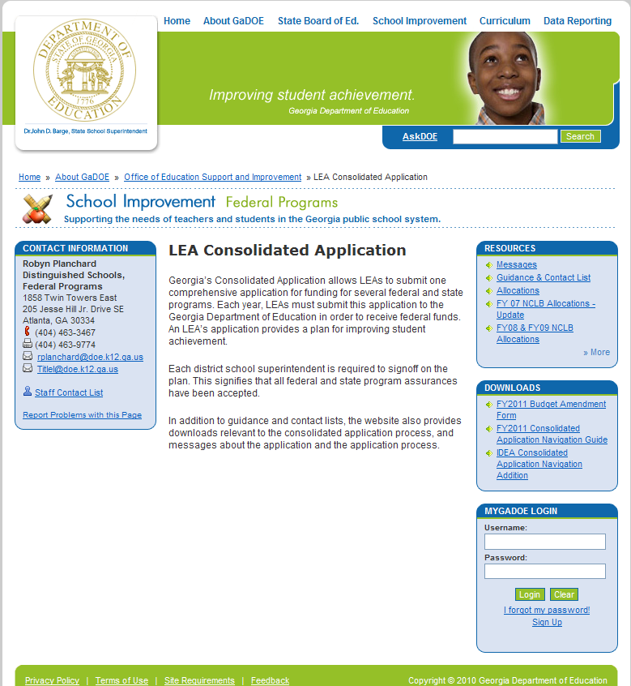
Downloads Section

MyGaDOE Portal Login

Logging into the MyGaDOE Portal
- Within the LEA Consolidated Application Website, enter you username and password to log into the MyGaDOE portal.


Use this URL during training only.

During training, we will log into a training server.
- In the address toolbar of the web browser, type the following url and press the Enter key on the keyboard.
https://portaluat.doe.k12.ga.us/Login.aspx
- Enter your Username and password, click Login. Your Username is your email address. If you have forgotten your password, select I forgot my passphrase!
- Once you are logged into the MyGaDOE portal, select Consolidated Application in the left-hand organization bar.
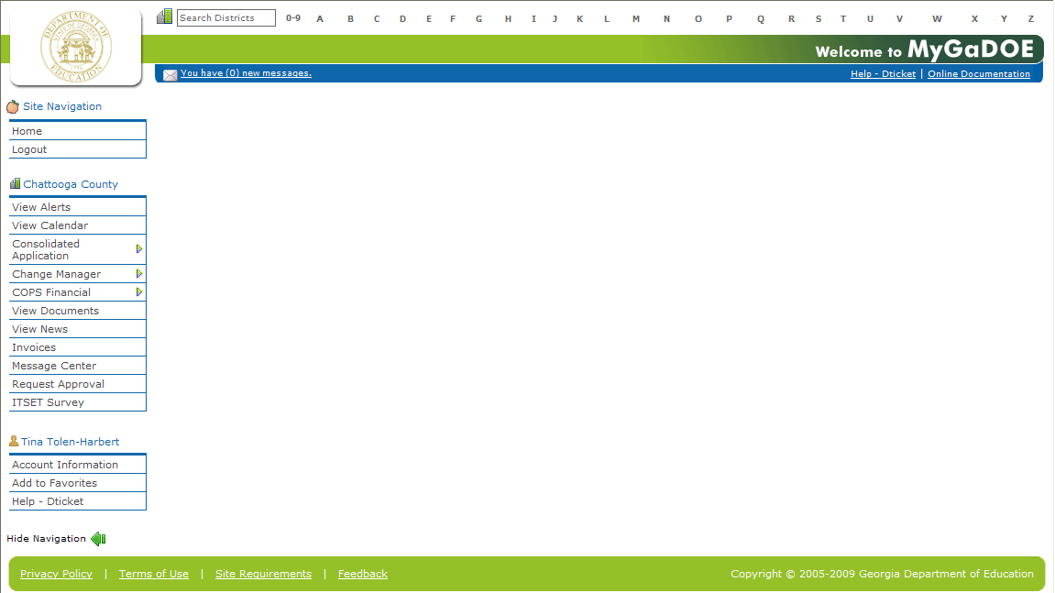
- A fly-out menu appears. Select Application.
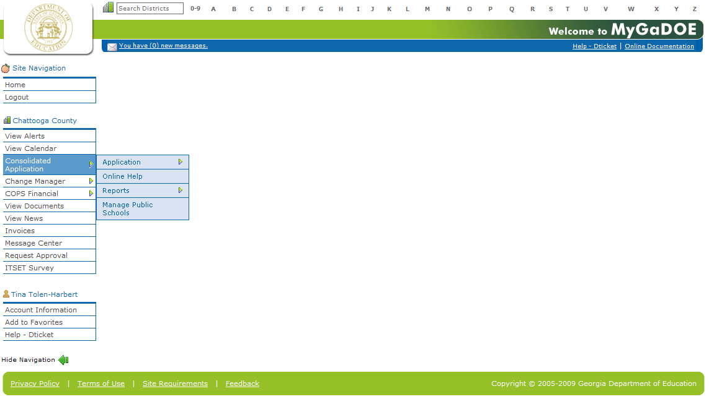
- The Consolidation Application page appears inside of the User Interface (UI). Note: The Navigation Menu is now located to the left of the page.
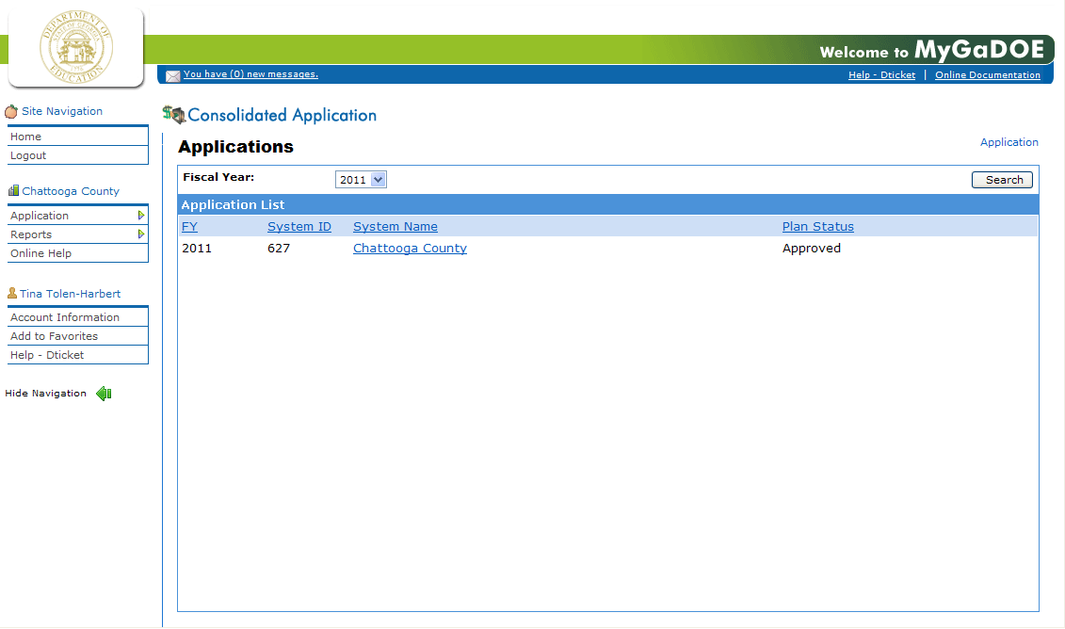
- Click the System Name for the appropriate fiscal year you would like to work within.
Reviewing the Work Flow
Everything begins with the Consolidated Application Coordinator as identified using the provisioning process within the MyGaDOE portal. The Consolidated Application Coordinator(s) will enter information for a district within this database. Superintendents will sign-off.
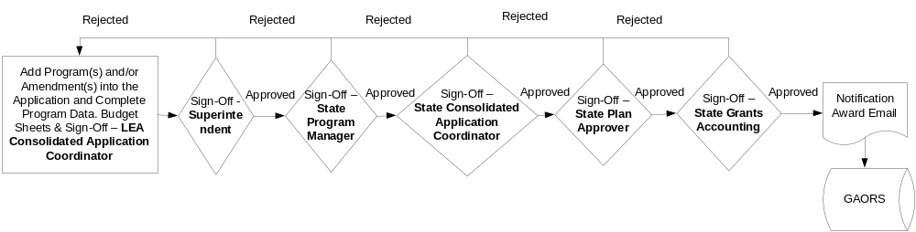

Reviewing the Navigation Screen
As you navigate through the application, many pieces of information will remain onscreen.
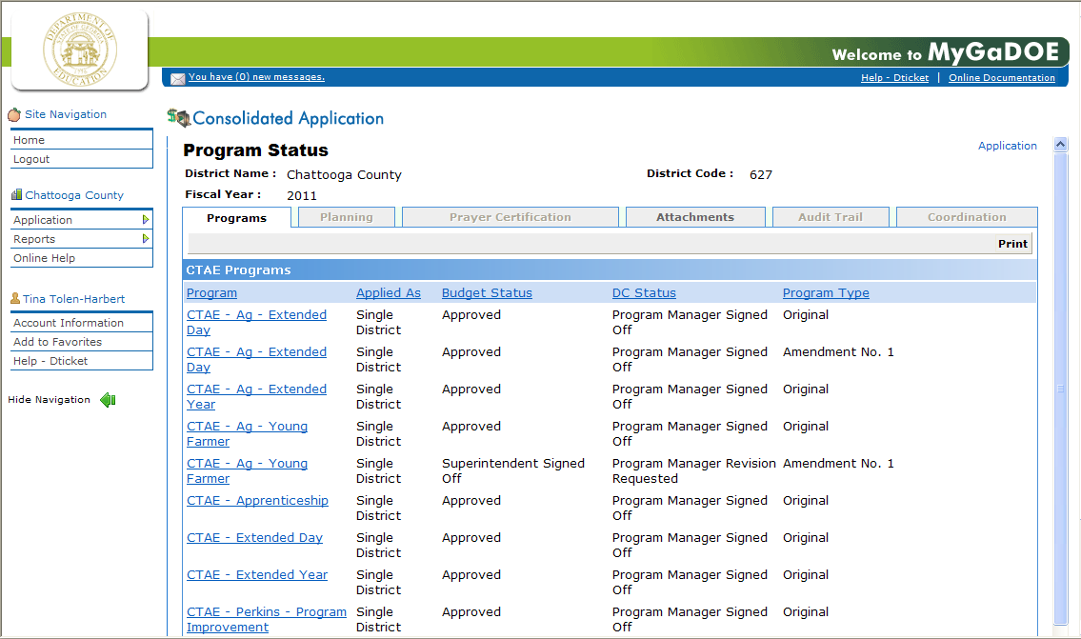
Site Navigation

1
4
Application Navigation
Program Navigation
2
3

Program-specific questions should be directed to the State Program Manager for a specific program.

Navigation | Purpose
1 – Site Navigation | The Site Navigation will remain onscreen as long as you are logged into the LEA Consolidated Application.
2 – Application Navigation | The Application Navigation panel allows navigation to screens of information pertaining to the entire application.
3 – Program Navigation | The Program Navigation panel controls individual programs within the LEA Consolidated Application.
4 – Application Navigation Bread Crumbs | These “bread crumbs” show a link for each level you go within the application. To return to the main program view for the previously-chosen Fiscal Year, select Programs.
Completing Application Data

Plan Descriptors
1
Step

Responsible Role(s):
- Consolidated Application Coordinator
- Superintendent
- State Plan Approver
- State Program Manager
- State Grants Accounting
This section provides narratives of all ESEA Plan Descriptors and Professional Learning Implementation Plan requirements. Local educational agencies (LEAs) must respond to each descriptor. Descriptors from the application will be displayed.
- Click the Planning tab.
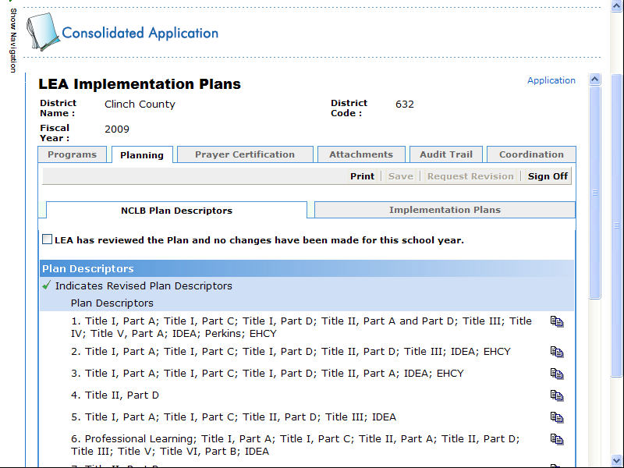
No Changes were made.
Save frequently.
Edit.
Districts will need to identify which items were changed from last year’s application by, using the blue colored highlight and strikethrough feature
- If changes are not needed from last year’s descriptors, place a check mark in the box next to LEA has reviewed the Plan and no changes have been made for this school year.
- If changes are needed from last year’s descriptors, select the Edit icon to the right of the specific descriptor to modify.
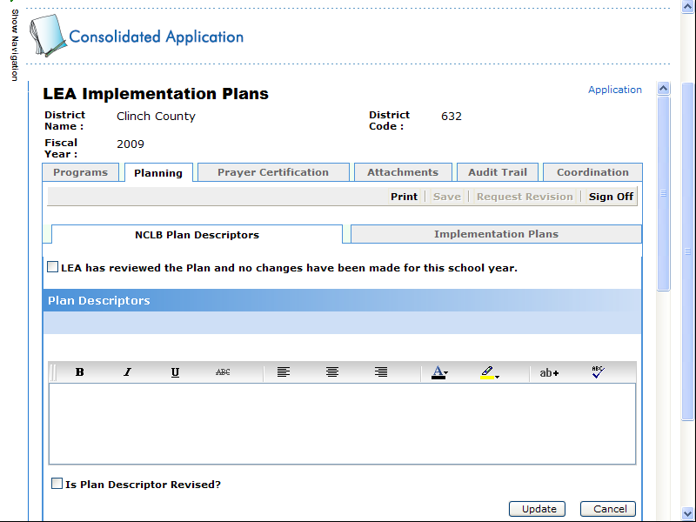
Check this box if the descriptor is revised.
Select Update to save any revisions.
- Within the Edit mode for a description, type the updated descriptor > select the checkbox for “Is Plan Descriptor Revised?” use the blue colored highlight and strikethrough feature to indicate changes for each Plan Descriptor, and then select Update.
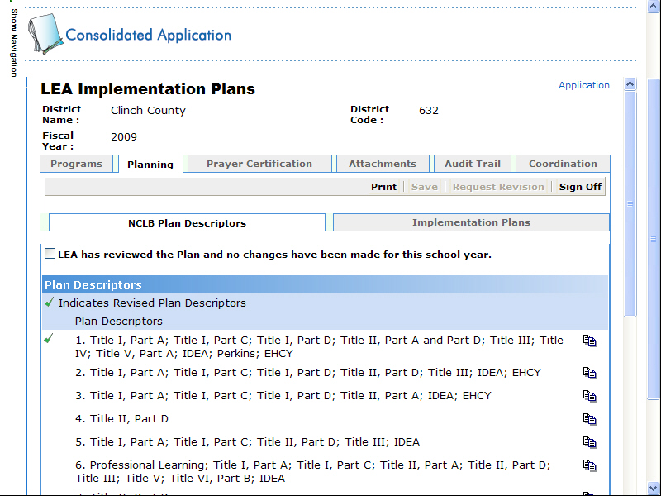
Note this descriptor was revised.
Note the check to the left of the updated descriptor.

LEA Implementation Plans
Performance Goals from the previous year’s application will be displayed. Uploaded files are allowed (directions are within pages 10-11) and do not have to be added within the online application.
- Click the Implementation Plans tab.
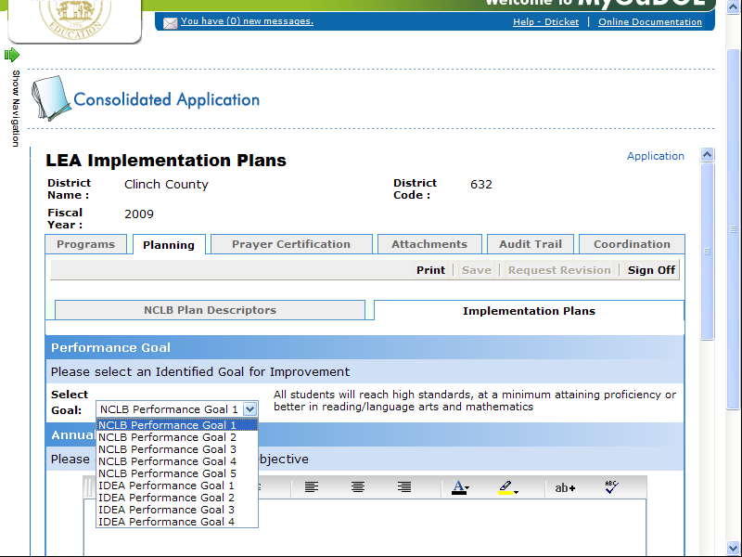
- Select the goal from the drop-down menu update individual goals.
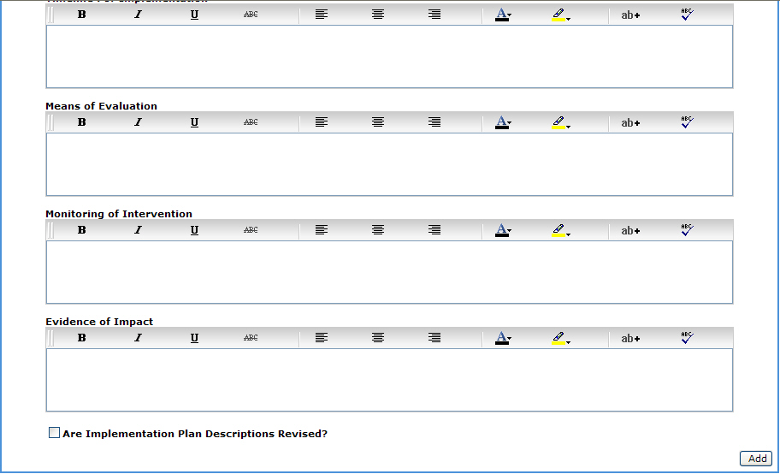
Check this box if the descriptor was revised.
- Select the checkbox for “Are Implementation Plan Descriptions Revised?” and the Update button to save changes.

Prayer Certification
In order to receive funds under the ESEA, a local educational agency (LEA) must certify in writing to the Georgia Department of Education (GaDOE) that no policy of the LEA prevents, or otherwise denies participation in constitutionally protected prayer in public elementary and secondary schools as set forth in this guidance. An LEA must provide this certification to the GaDOE by October 1 of each subsequent year during which the LEA participates in an ESEA program. LEAs must provide certification on Constitutionally Protected Prayer through the LEA Consolidated Application.
- Click the Prayer Certification tab.
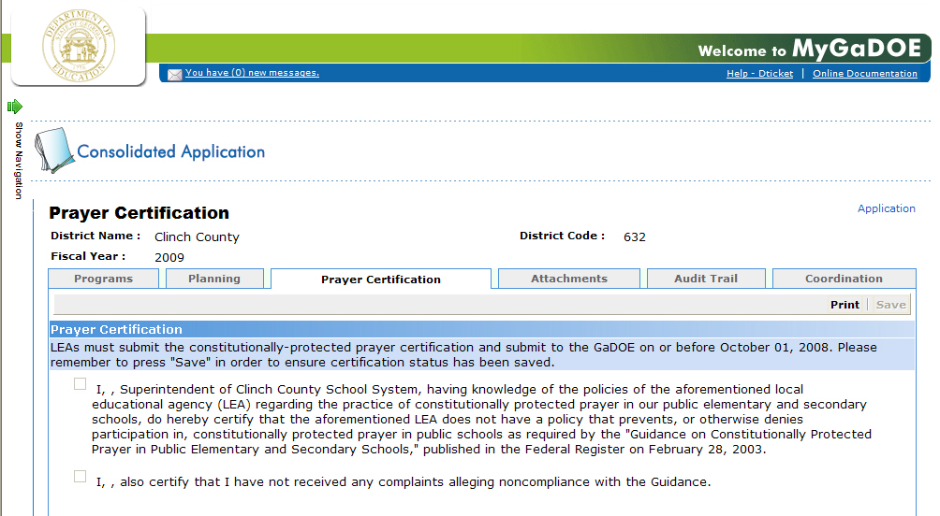
The Superintendent is the only user that can select both checkboxes. Once this has been accomplished (by the Superintendent), select Save.

Uploading File Attachments
This is the location to upload any electronic files within the application. There should be no file attachments added to the ESEA Plan Descriptors. File attachments are allowed for other sections of the application.
- Click in the attachment description field and type a description for the file that is being uploaded.
- Click the Browse button to upload the document.
- Navigate through this screen and select the document to upload, click Upload.
- Return to the main Application screen by clicking on the Programs link.

Viewing the Audit Trail within the
LEA Consolidated Application
- Click the Audit Trail tab.
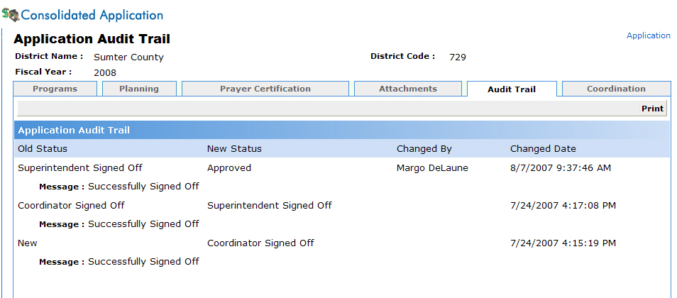
This screen displays the audit trail generated within the application identifying the previous status, current status, who made the change, and change date.

Coordination
- Click the Coordination tab.
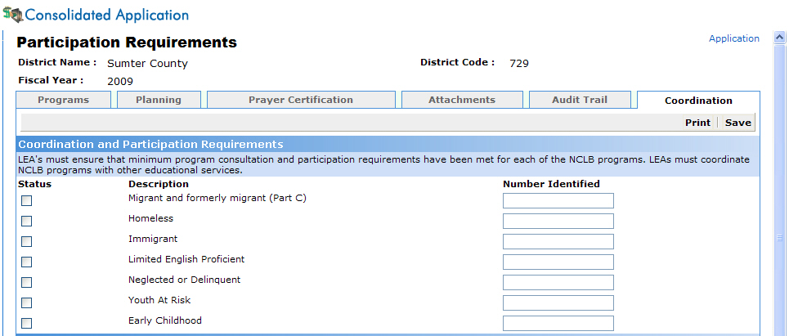
LEA’s must ensure that minimum program consultation and participation requirements have been met for each of the ESEa programs. LEAs must coordinate ESEA programs with other educational services.
- Select the checkbox if your district participates in the description program to the left. If a checkbox is selected for a program, identify the number of students participating in this program on the right.
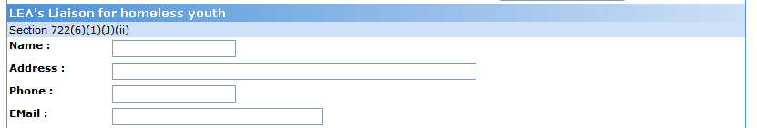
- Within the LEA’s Liaison for homeless youth section, identify the name, address, phone, and e-mail address of the LEA’s Liaison for homeless youth.
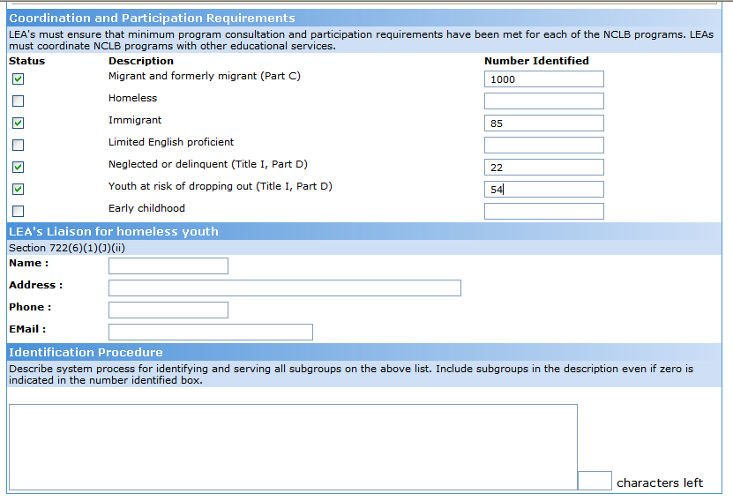
- Within the Identification Procedure section, describe the district’s process for identifying and serving all subgroups for the checkbox that was selected in the above list. Include subgroups in the description, even if zero is indicated in the number identified box.
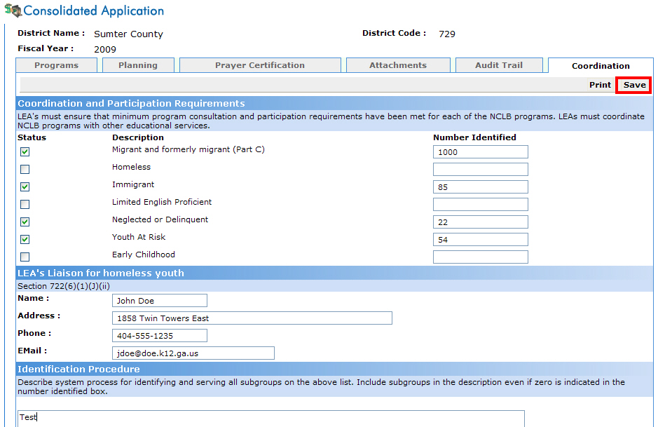
Save

- Once the items within this tab have been completed, click Save.
State Plan Sign-Off

The State Plan will have to be signed-off by the State Plan Approver before the sign off link is available for individual programs within the consolidated application.
2
Step

Responsible Roles:
- LEA Consolidated Application Coordinator
- Superintendent
- State Program Manager
- State Consolidated Applications Coordinator
- State Plan Approver
- State Grants Accounting

Consolidated Application Coordinator Sign-Off
- Within the Planning tab, verify that the Planning Descriptors are complete, saved, and ready to sign-off.
- Click the Sign-Off button.
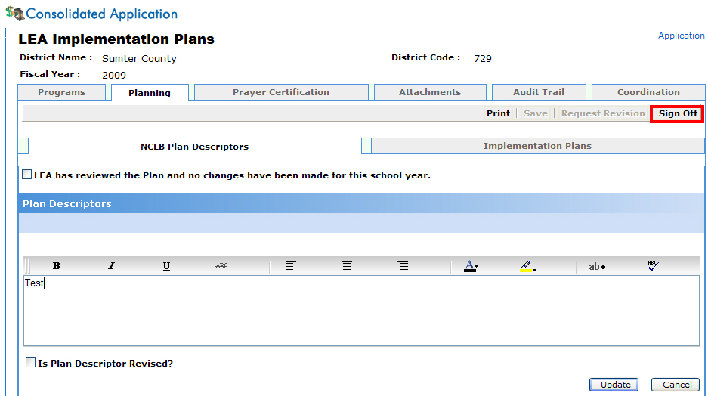
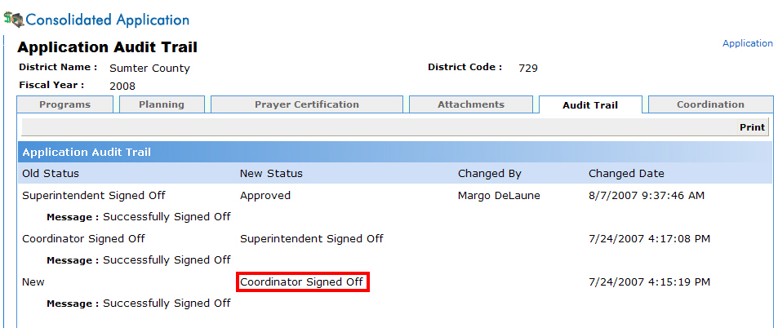
LEA Consolidated Application Coordinator has signed off

Superintendent Sign-Off
The Superintendent will receive an email message requesting his/her approval of the program.
- The Superintendent will be able to click the Website link within the Superintendent approval email message, follow steps 1-5 on pages 4-5 then continue with these directions.
- Click the Planning tab.
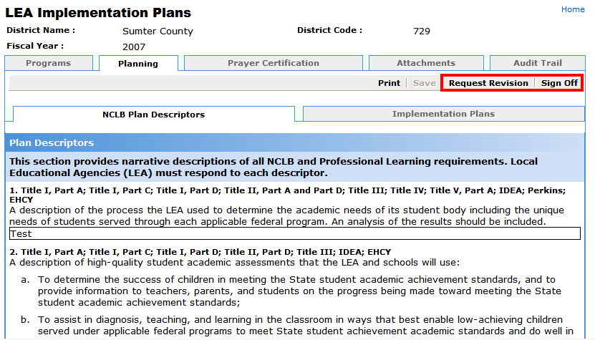
- The Superintendent will need to review the information submitted and either Sign-Off (approve) or Request a Revision.

Approving State Plan
- Click the Sign-Off button to approve the state plan.
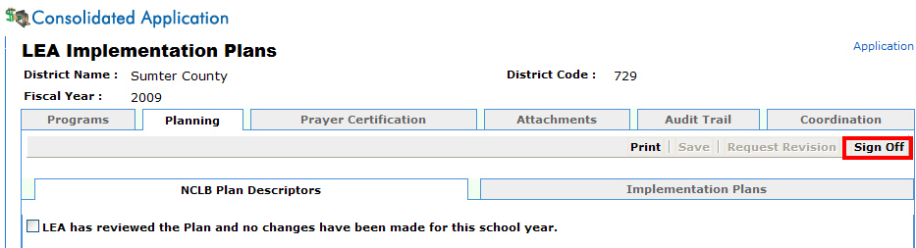
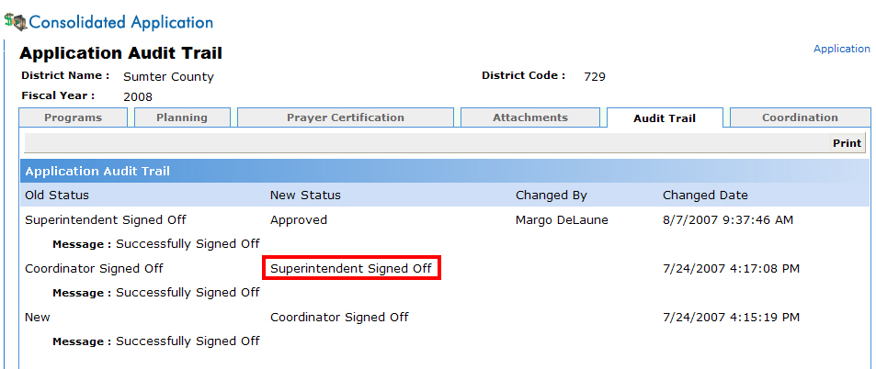
Plan has been signed off by the Superintendent.

At this point, the LEA Consolidated Application Coordinator, State Program Managers, State Consolidate Application Coordinator and State Plan Approver will receive an email message stating the Superintendent has signed-off on the State Plan. Program managers will have five business days to review and sign-off on the plan.

Requesting State Plan Revisions
- Click the Request Revision button.
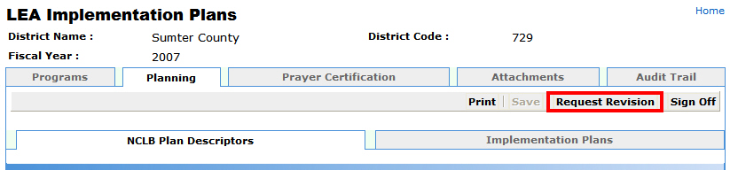
- Enter a reason for the revision and click Submit.
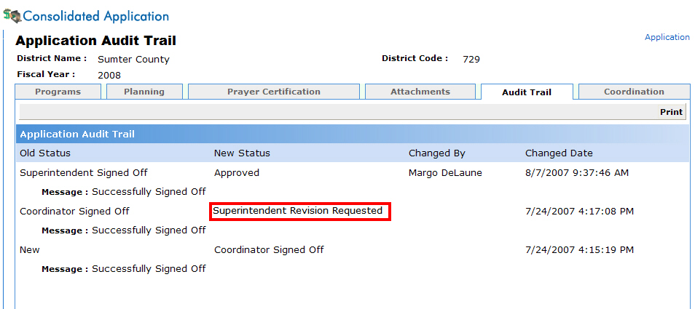
State plan revision has been requested by the Superintendent.

- At this point, an email message will be delivered to the LEA Consolidated Application Coordinator requesting a revision before the Superintendent will approve the program.

State Plan Approver Sign-Off
The State Plan Approver, State Consolidated Application Coordinator, and all Program Managers will receive an email message requesting his/her approval of each district’s state plan once the Superintendent has signed off. Each Program Manager will have five business days to review and comment on the plan. Each program manager will forward an email to the State Consolidated Application Coordinator who will review and compile all approvals/requests for revision. The State Consolidated Application Coordinator will forward approvals or requests for revision to the State Plan Approver. The State Plan Approver will sign-off approving the plan or request an LEA revise the plan. If a revision is requested the LEA will have five business days to complete and resubmit the plan.
Emails are automatically sent to the school district (Superintendent and Consolidated Application Coordinator) once its plan has been approved or a revision is requested by the State Plan Approver.
Adding Program(s) into the Application
- Within the Programs tab, click the drop-down menu to the right of Programs to add programs into the application.
3
Step
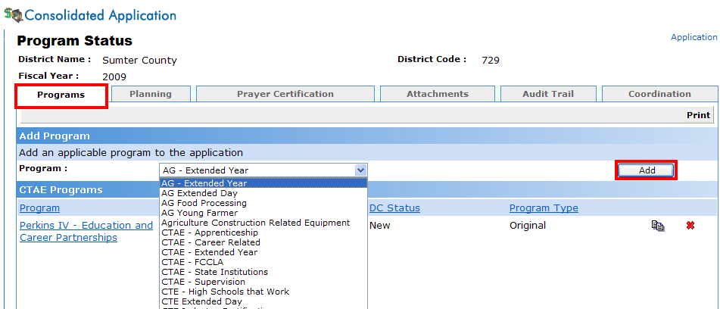
Add Programs
Previously-added Programs

Programs Available to Add within the System

Responsible Role:
- LEA Consolidated Application Coordinator
- Superintendent
- State Program Manager
- State Consolidated Applications Coordinator
- State Plan Approver
- State Grants Accounting
Current Programs Available: Ag Extended Day; Ag Extended Year; Ag Young Farmer; CTAE Apprenticeship; CTAE, Extended Day; Perkins IV-Education and Career Partnership; Perkins IV- Professional Development; Perkins IV-Program. Title Programs: (Education for Homeless Children and Youth, Schoolwide Consolidation of Funds; Title I-A; Title I-D, Delinquent Project; Title I-A, Distinguished Districts; Title I-C Migrant Education; Title II-A, Improving Teacher Quality; Title III-A Immigrant; Title III-A, LEP; Title VI-B, Rural and Low Income; Professional Learning; Exceptional Students: Special Ed-State Preschool; Special Ed Federal Preschool; Special Ed-IDEA VIB-Flow-through.
- Select Add to save the entry.
The LEA Consolidated Application Coordinator can always return at a later date to add additional programs as they are available within the system.

Information Displayed on the Programs Main Screen
Selection | Action
Program | Individual program applied for.
Applied As | Single District or Consortium. Consortium is no longer chosen by the user. This feature can only be defined by the State Program Manager for a particular program.
Status | New – Application has not been signed-off  Coordinator Signed-Off – Application is awaiting approval from the Superintendent.  Superintendent Signed-Off – Application is awaiting approval from the State Program Manager.  Superintendent Revision Requested – Application has been rejected by the Superintendent.  Program Manager Revision Requested – Application has been rejected by the State Program Manager.  Approved – State Program Manager has approved the application and the funds are now available in GAORS.
Data Collections Status (DC) | New – Data Collection form has not been signed-off.  Coordinator Signed-Off – Data Collection form is awaiting approval from the Superintendent.  Superintendent Signed-Off – Data Collection form is awaiting approval from the Program Manager.  Program Manager Signed-Off – Program Manager has approved the Data Collection form.
Program Type | Original – This is the original application for this program.  Amendment # - This is amendment number # for this program (Example: Amendment No. 1, Amendment No. 2, etc.).

Completing Program Data
Once the Consolidated Application Coordinator adds program(s) into the application he/she can complete the application data for each program.
4
Step

Responsible Roles:
- LEA Consolidated Application Coordinator
- Superintendent
- State Program Manager
- State Consolidated Applications Coordinator
- State Plan Approver
- State Grants Accounting

- Within the Programs tab, click a Program Name to update.

Title I-A
- Click the Title I-A link.
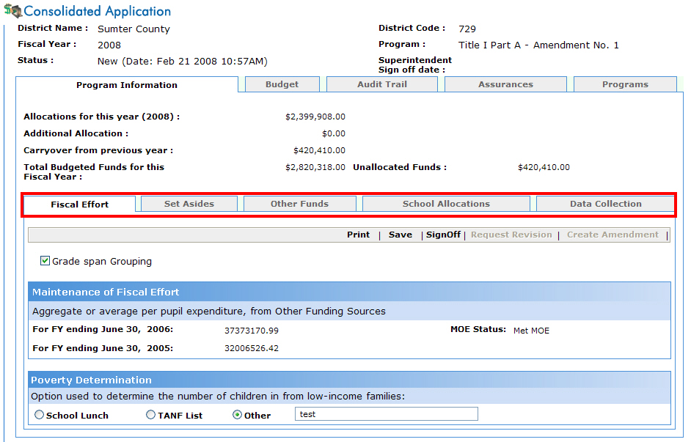

- Within the Fiscal Effort tab, select the check box of grade span grouping if a districts is using this method to group their Title I schools.
The online application will automatically populate the calculation on the maintenance of fiscal effort.
- Select Save to save these changes.
- Within the Set-Asides tab, select the description from the drop-down menu to indicate the administrative funds that will not be a part of the per pupil allocations. Add the amount and a description explanation. Select the Add button to save the change.
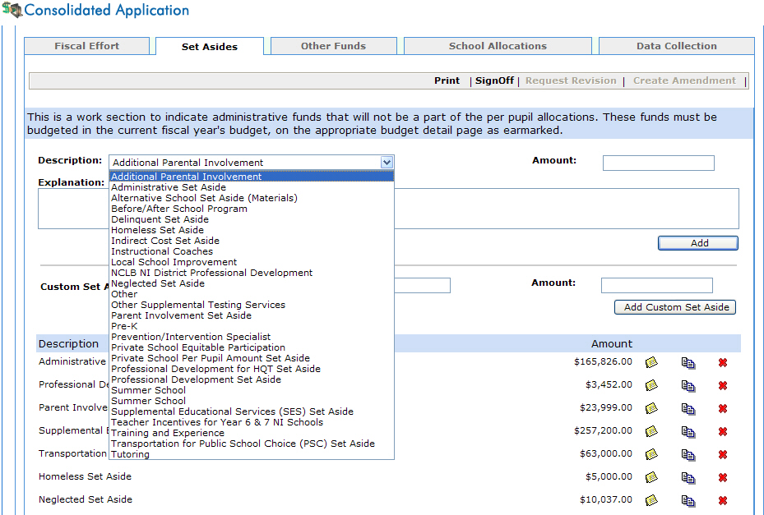
- Enter a customize set-aside in the Custom Set-Aside Description field. Click the Add Custom Set-Aside button.
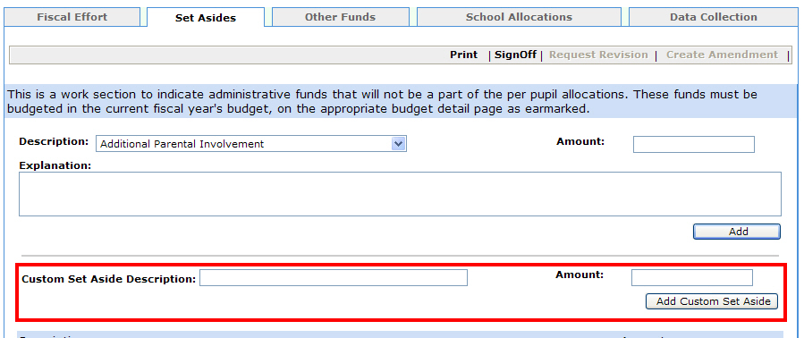
These funds must be budgeted in the current fiscal year’s budget, on the appropriate budget detail page as earmarked.
- Select the Other Funds tab.
This tab is for Other Funding Sources for Public School Choice, Supplemental Services and Professional Development. Please list funding sources and amounts that will be used to off-set the required spending amounts for public school choice and supplemental services.
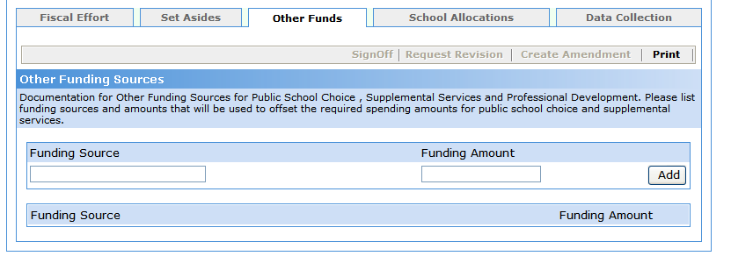
- Identify the funding source, funding amount, and the purpose of the funding, i.e., Choice or SES, or Title II-A-Request for Highly Qualified $2,000 and then select Add.
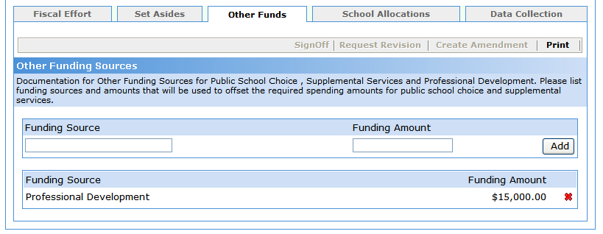
- Select the School Allocations tab.
Type SWP = school wide program

Type TA = targeted assisted program

Carryover funds cannot be added for the original application.

Carryover funds are only for amendments.

Public Schools

Private Schools

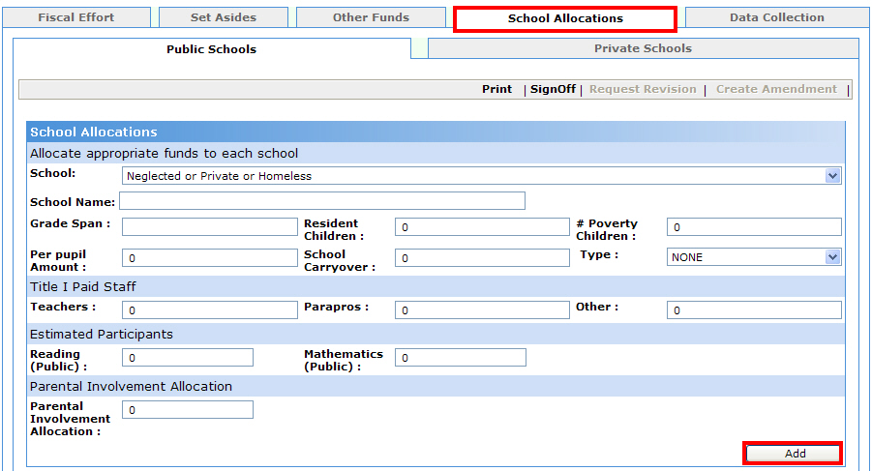
Allocations for all schools are to be entered within this tab (as well as private, homeless, and neglected), whether eligible or not.
- Once all fields for each school have been completed, click the Add button.
- Once schools have been added, scroll to the bottom of the window for the following view.
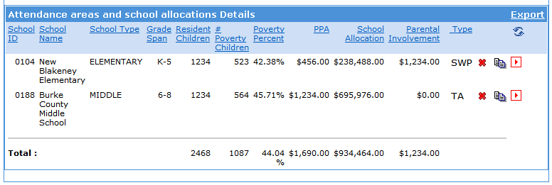
Delete Expand
Edit
All schools should be entered whether eligible or not.
- Click the Expand icon for one of the schools.
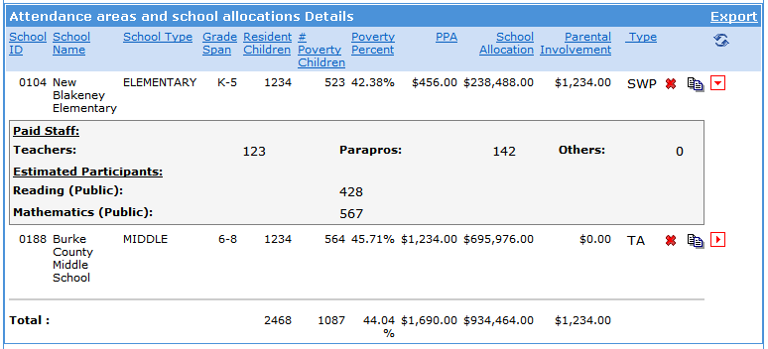
Expand
Notice the additional information that is displayed on the screen once the expand button has been chosen.
- Click the Expand button a second time for the same school.
The additional details will no longer be displayed.
- Click on any of the column headings and sorting will be applied to the heading chosen.
Note: Select additional column headings to create a custom sort. As additional columns are selected they are added to the sort criteria. That is, the list is sorted by the first column clicked, then the by the second column within the first and so on.
- Selecting the Reset Sort button will remove all sort criteria.
Reset Sort
- Select the Data Collection tab.

Four Data Collection Forms are available:

Homeless

Neglected & Delinquent

Public School Choice

Supplemental Educational Services

Four Data Collection forms are available:
Homeless, Neglected & Delinquent, Public School Choice, and Supplemental Educational Services.
These forms do not have to be completed prior to submitting for approval from the state program manager.
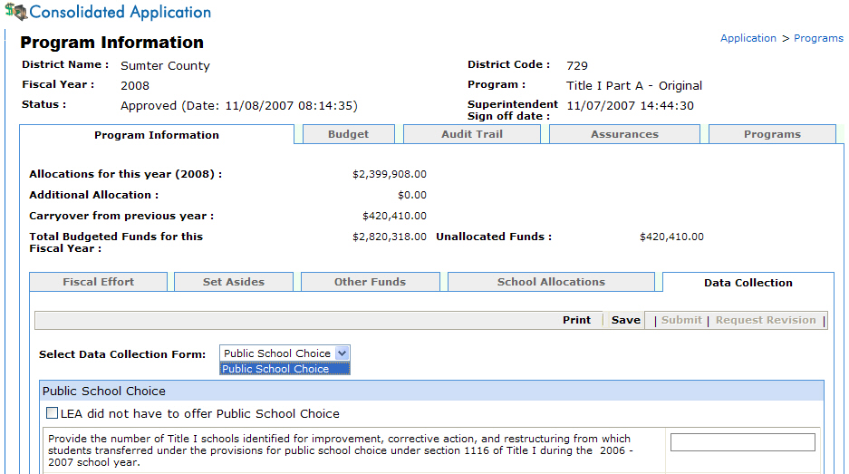
Save
- Complete the fields within these forms, as appropriate.
- Click the Save button at the top of this screen to save your changes.
Homeless Form: Examples of community-based sources for the night time residence of homeless children and youth residing in the LEA might include: homeless shelters, transitional housing programs, local emergency assistance agencies, Division of Family and Children Services, faith-based organizations, hotels, and motels. Examples of school-based sources might include: social workers, counselors, attendance workers, enrollment clerks, teachers, principals, and bus drivers.
- Return to the Programs Main tab by clicking the Programs link.

Title I-C Migrant Ed
- Within the main Application screen, select the link for
Title I-C Migrant Ed.
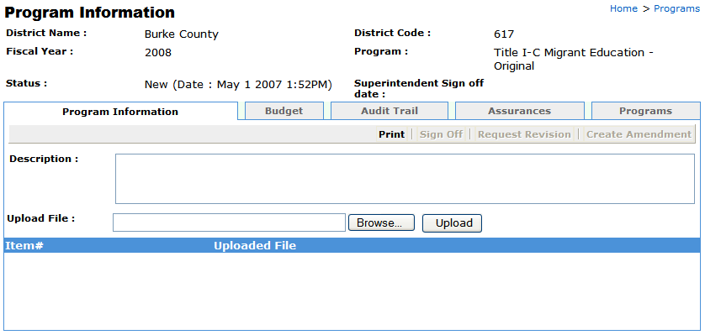
ABC
123
Two draft versions of a detailed MEP project implementation plan templates will be available for pilot project use in FY.
FY MEP Project Implementation Plan - Regular School Year Supplemental Services
FY MEP Project Implementation Plan - Summer Supplemental Services
These pilot project documents will tie in closely with the on-going efforts and results of the state and local migrant student needs assessment process. The state Migrant Education program (MEP) staff will be working closely with the LEAs throughout FY to test the use of these two project planning tools. LEAs are not required to complete these documents for FY projects. However, they are encouraged to participate in piloting their use throughout the year to determine the final format and structure of the state’s MEP project plan documentation process.
Additionally, LEAs will have the opportunity to pilot two related project evaluation templates that will document the outcomes and success of the project plans.
FY MEP Project Evaluation - Regular School Year Supplemental Services
FY MEP Project Evaluation - Summer Supplemental Services
More detailed information related to the state’s goal in developing and piloting these project implementation plan documents is available from the state office and the four regional Migrant Education Agencies.
- Click in the attachment description field and type a description for the file that is being uploaded.
- Click the Browse button to upload the document.
- Navigate through this screen and select the document to upload, click Upload.
- Return to the main application screen by clicking the Programs link.

Title II-A Improving Teacher Quality
- Within the main Application screen, select the link for
Title II-A Improving Teacher Quality.
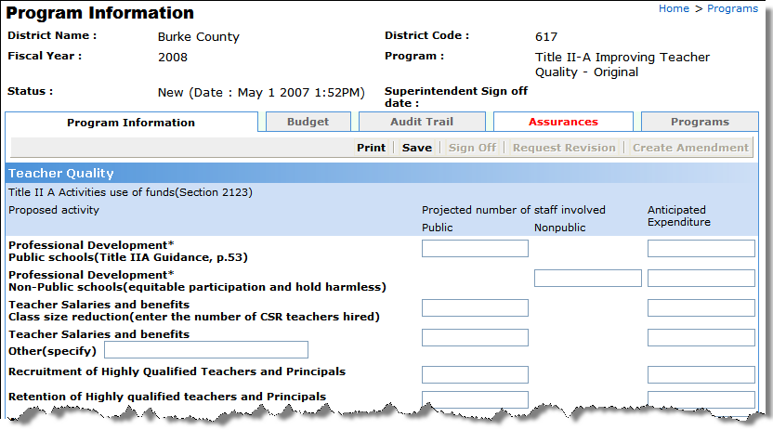
- Complete the appropriate fields and select Save.
- Return to the main Application screen by clicking the Programs link.

Title III-A LEP
- Within the main Application screen, select the link for
Title III-A LEP.
- Select the Program Information tab and enter details about the district’s Title III program plan. In Part 1 of the program plan, describe funded activities and expected student progress. Ensure that funded activities promote: 1) language acquisition 2) achievement in the academic content areas and 3) ESOL-related professional development.
Note: In Part 2 of the program plan, describe the district’s method of Title III program evaluation.
- Click Save.
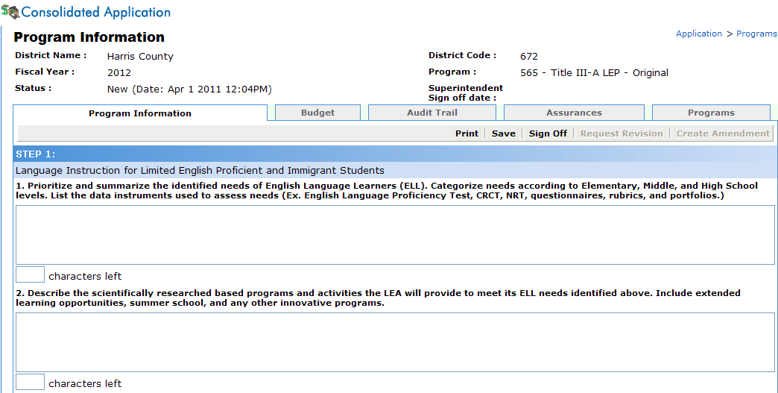
- Return to the main Application screen by clicking the Programs link.

Title III-A Immigrant
- Your district may be notified that it qualifies for Title III-A Immigrant funds. Upon notification, select the link for Title III-A Immigrant from the main Application screen.
- Select the Program Information tab and enter details about the district’s Immigrant program plan. Immigrant grant funds must be used to pay for activities that provide enhanced instructional opportunities for the district’s immigrant students.
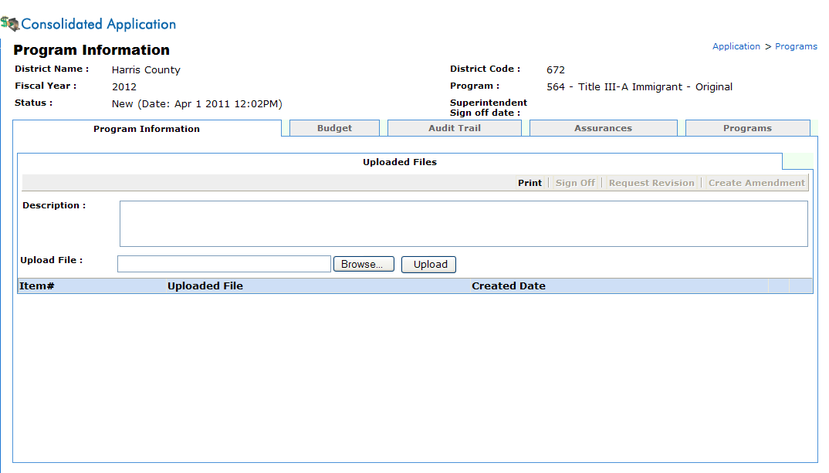

Title VI-B Rural and Low Income
- Within the main Application screen, select the link for
Title VI-B Rural and Low Income.
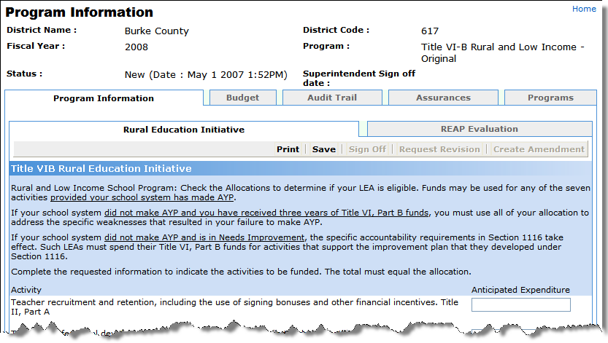
- Select the Program Information tab.
- Within the Rural Education Initiative tab, complete the appropriate fields and select Save.
- Select the Data Collection tab.
The data for this report must reflect the current school year. Choose yes or no for each of the seven activities indicating whether or not the LEA participated. For each activity that occurred in the LEA, enter the dollar amount spent in that particular activity.
- Complete the appropriate fields and select Save.
- Click the Submit button for the Coordinator to submit to the Superintendent for approval.
- The Superintendent clicks the Submit button to submit to GaDOE.
- Return to the main Application screen by clicking the Programs link.

Ag Construction Related Equipment
- Within the main Application screen, select the link for
Ag Construction Related Equipment.
- Select the Grant Proposal tab.
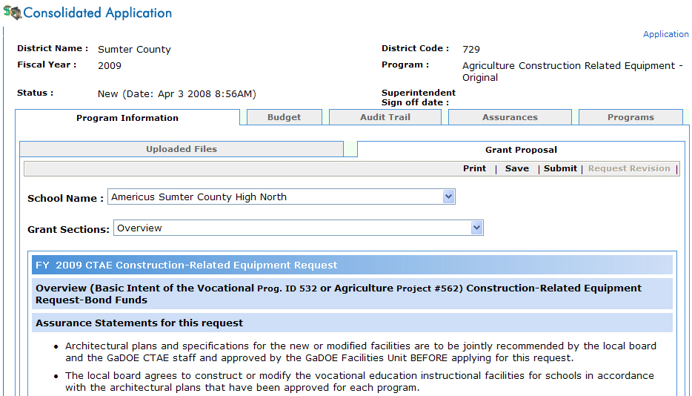
- Districts will need to select the Agree radio button at the bottom of this screen, then select Save.
- Return to the main Application screen by clicking the Programs link.

Career Development
- Within the main Application screen, select the link for
Career Development.
- Select the Grant Proposal tab.
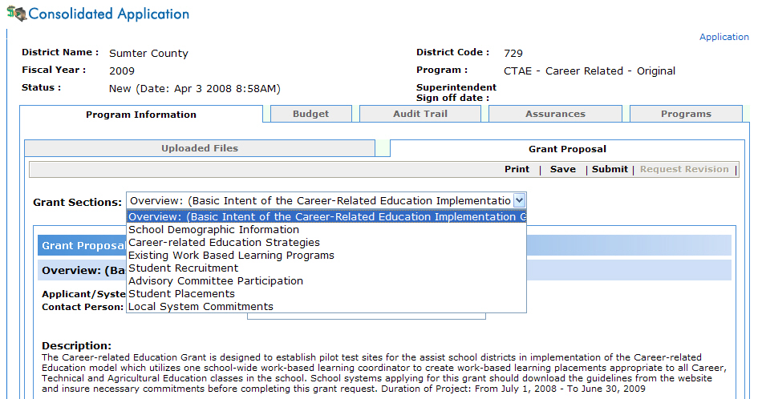
- Complete and save each grant section.
- Return to the main Application screen by clicking the Programs link.

Career, Technical and Agricultural Education (CTAE) – CTE Youth Apprenticeship
- Within the main Application screen, select the link for
CTAE – CTE Youth Apprenticeship.
- Select the Grant Proposal tab.
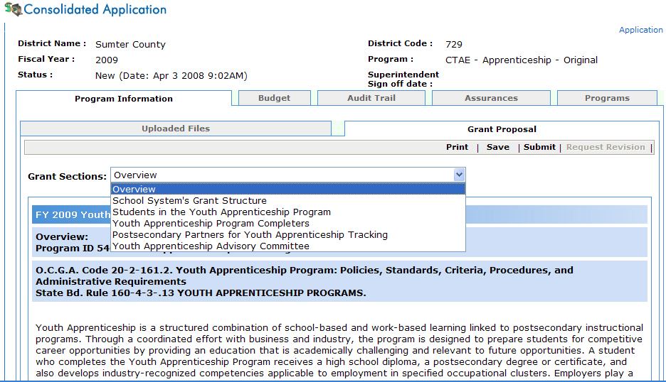
- Complete and save each grant section.
- Return to the main Application screen by clicking the Programs link.

Career, Technical and Agricultural Education (CTAE) – Supervision
- Within the main Application screen, select the link for
CTAE – Supervision.
- Select the Grant Proposal tab.
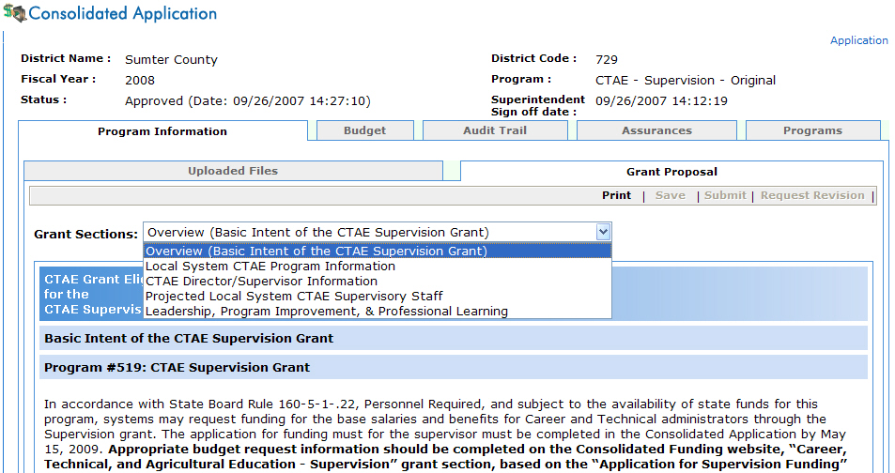
- Complete and save each grant section.
- Return to the main application screen by clicking the Programs link.

Industry Certification
- Within the main application screen, select the link for
Industry Certification.
- Select the Grant Proposal tab.
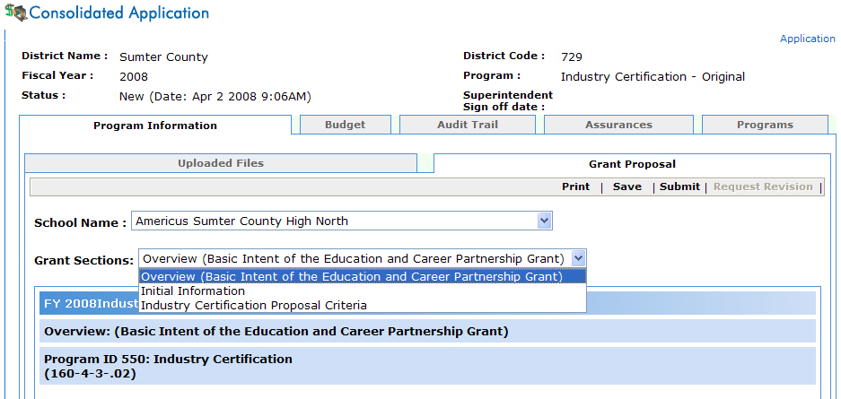
- Complete and Save each grant section.
- Return to the main Application screen by clicking the Programs link.

Perkins IV - Education and Career Partnerships
- Within the main Application screen, select the link for
Perkins IV – Education and Career Partnerships.
- Select the Grant Proposal tab.
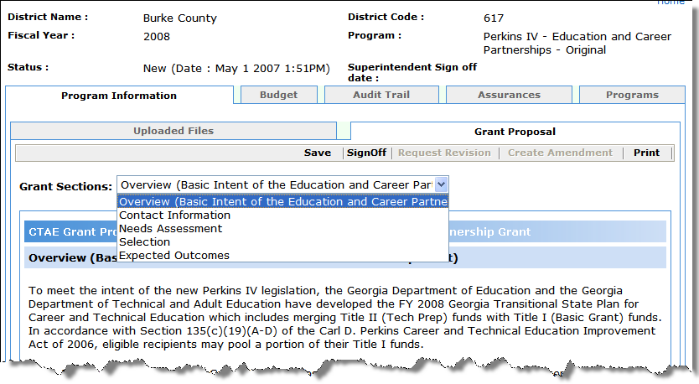
- Complete and save each grant section.
- Return to the main Application screen by clicking the Programs link.

Perkins IV – Professional Development
- Within the main Application screen, select the link for
Perkins IV – Professional Development.
- Select the Grant Proposal tab.
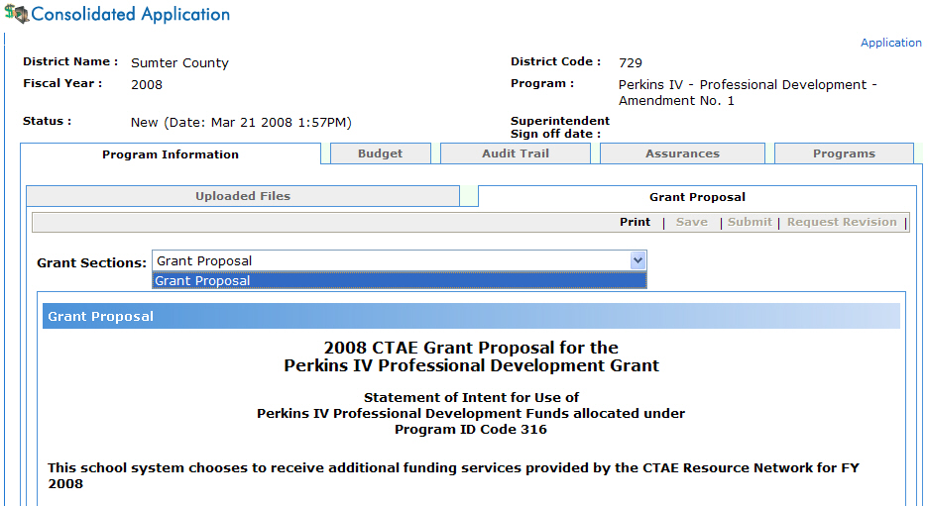
- Complete and save each grant section.
- Return to the main Application screen by clicking the Programs link.

Perkins IV Program Improvement
- Within the main Application screen, select the link for
Perkins IV Program Improvement.
- Select the Grant Proposal tab.
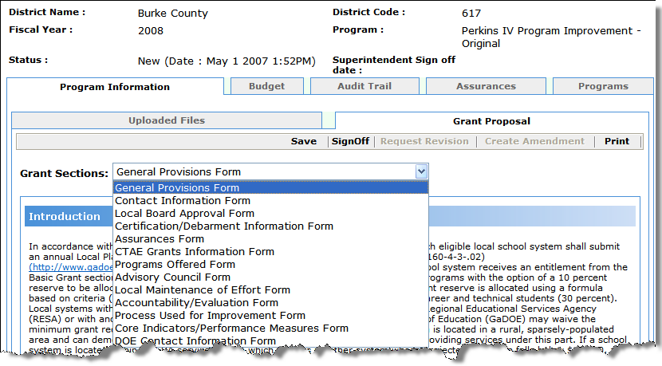
- Complete and save each grant section.
- Return to the main Application screen by clicking the Programs link.

Vocation Construction Related Equipment
- Within the main Application screen, select the link for
Vocation Construction Related Equipment.
- Select the Grant Proposal tab.
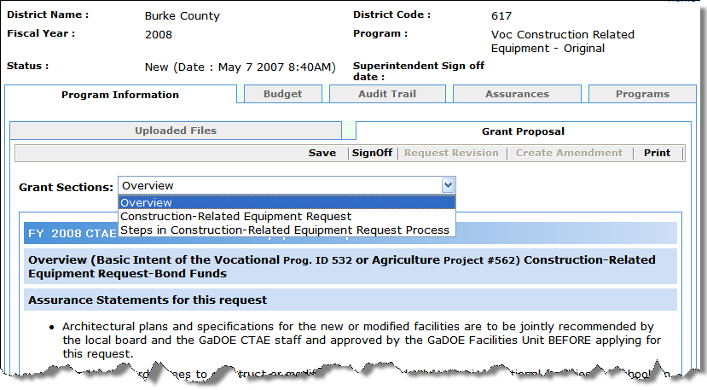
- Complete and save each grant section.
- Return to the main Application screen by clicking the Programs link.
Completing Budget Sheets
5
Step

- Within the Programs tab, select the program of the budget to edit.
- Click the Budget tab.
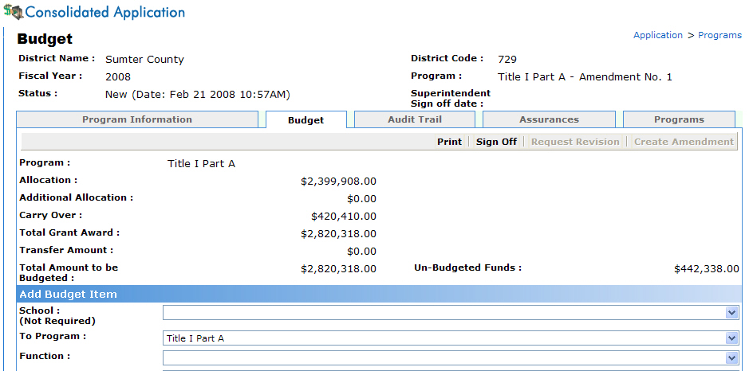
Responsible Roles:
- Consolidated Application Coordinator
- Superintendent
- State Plan Approver
- State Program Manager
- State Grants Accounting

- Complete the Budget form for each line item within the selected program.
Note: Only valid combinations will be available for selection within this screen.
Budget Item | Description
To Program | If your chosen program allows transfers, you will see a list of available programs you can transfer into.
Function | Function code from the Chart of Accounts.
Object | Object code from the Charts of Accounts.
Units | Number of Units
Price | Amount per Unit
Amount | Calculated value based upon the number of units x amount per unit
Description | Line item description.
- Select Add.
The Budget Detail section displays each budget item that has been completed within this program.
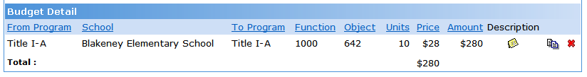
- Return to the main Programs screen by clicking the Programs tab or breadcrumb.
Individual Program Sign-Off
6
Step

Consolidated Application Coordinator Sign-Off
The Consolidated Application Coordinator will need to sign-off on each program to initiate the system sign-off process.
Responsible Roles:
- Consolidated Application Coordinator
- Superintendent
- State Plan Approver
- State Program Manager
- State Grants Accounting

- Within the Programs Main tab, select the program to sign-off on.
- Click the Sign-Off button.
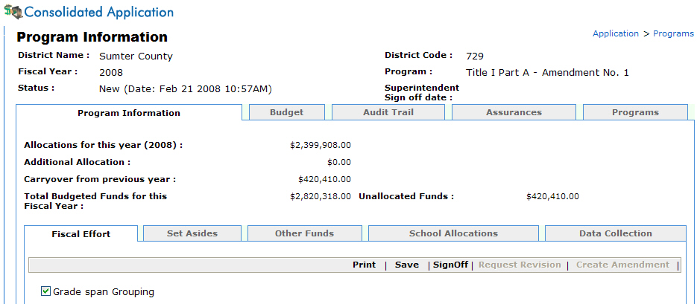

You will receive this message when trying to sign-off on any program if Step 2 has not been approved by the State Plan Approver.

- Select OK to sign-off.
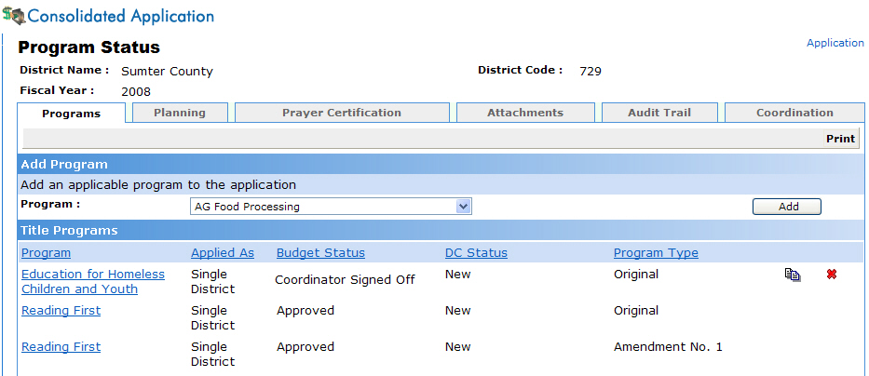
Consolidated Application Coordinator has signed-off

Superintendent Sign-Off
The Superintendent will receive an email message requesting their approval of the program.
- The Superintendent will be able to click the Website link listed within the Superintendent approval email message, follow steps 1-5 on pages 4-5, then continue with these directions.
Programs that are ready for the Superintendent’s approval are listed as Coordinator Sign-Off in the Status Field.
- Click the Program Name link that has a Coordinator Sign- Off status.
- The Superintendent will need to review the information submitted for the program and either Sign-Off (approve) or request a revision.

Approving Individual Programs

You will not be allowed to sign-off until every penny has been allocated.

- Click the Sign-Off button to approve the program.
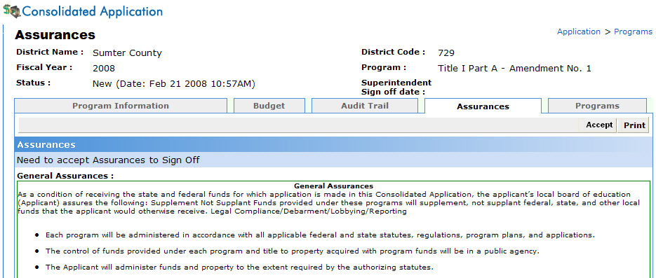
- The Superintendent will need to read the legal general and specific assurances for that particular program and select Accept.
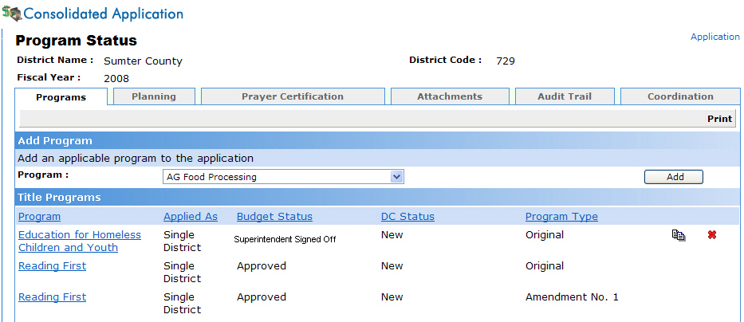
Program has been signed off by the Superintendent.

At this point, the Consolidated Application Coordinator and State Program Manager will receive an email message stating the Superintendent has signed-off on the program.

Requesting Individual Program Revisions
- Click the Request Revision tab.
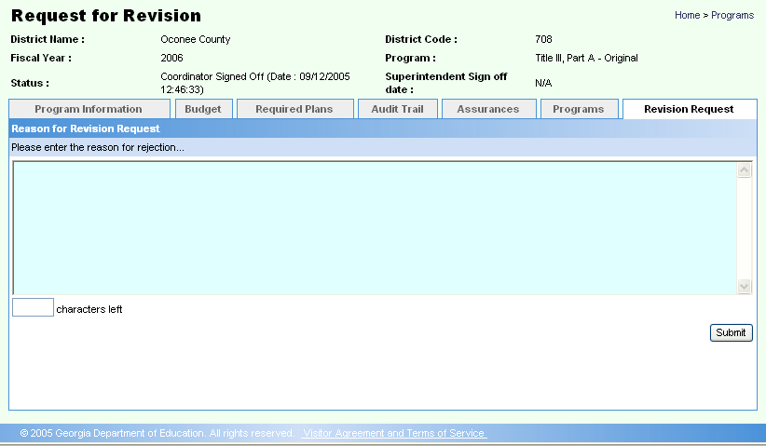
- Enter a reason for the revision and click Submit.
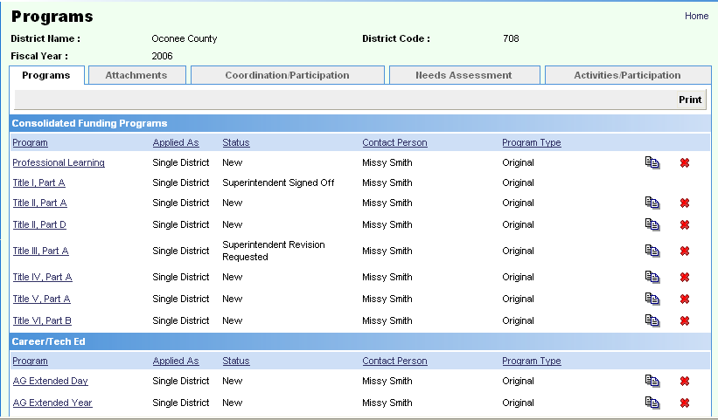
Program revision has been requested by the Superintendent.

- At this point, an email message will be delivered to the Consolidated Application Coordinator requesting a revision before the Superintendent will approve the program.

State Program Manager Sign-Off
The State Program Manager will receive an email message requesting his/her approval of the program once the Superintendent has signed-off. The approval/request revision process works exactly the same for the State Program Manager as the Superintendent.
Emails are automatically sent to the school system (Superintendent and Consolidated Application Coordinator) once they have been approved or a revision is requested by the State Program Manager.
It is important that program funds be expended exactly as stated in the application budget section for each program.
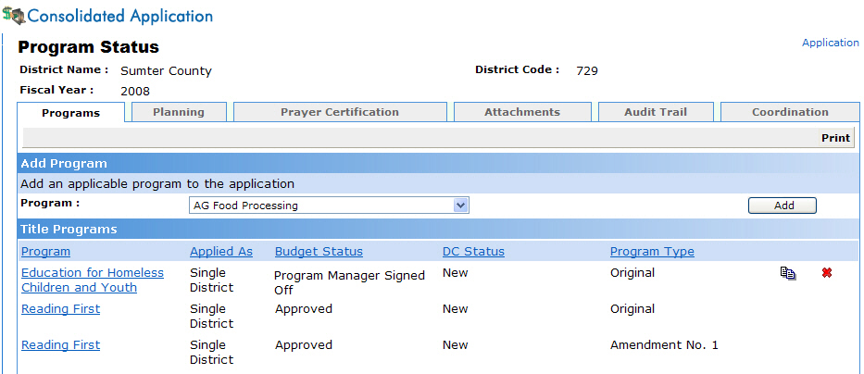
Program has been Approved by the State Program Manager.

State Grants Accounting Sign-Off
The State Grants Accounting will receive an email message requesting his/her approval of the program once the State Program Manager has signed off. The approval/request revision process works exactly the same for the State Grants Accounting as the Superintendent and State Program Manager.
Emails are automatically sent to the school system (Superintendent and Consolidated Application Coordinator) once they have been approved or a revision is requested by the State Grants Accounting.
It is important that program funds be expended exactly as stated in the application budget section for each program.
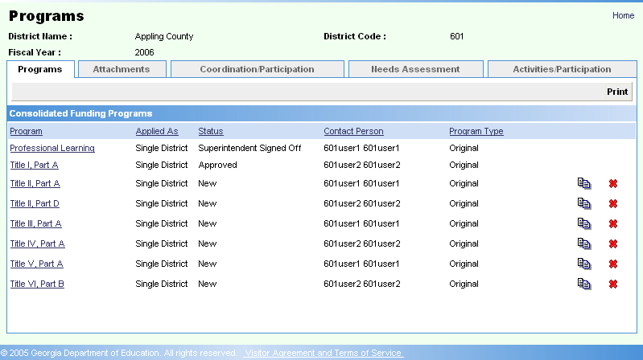
Program has been Approved by the State Program Manager.

Creating Amendments
7
Once the State Grants Accounting has signed-off on a program, districts can make amendments.
Step

(Optional)
- Within the Programs Main tab, select the program to Amend.
- Select Create Amendment.
Responsible Role:
- LEA Consolidated Application Coordinator
- Superintendent
- State Program Manager
- State Consolidated Applications Coordinator
- State Plan Approver
- State Grants Accounting

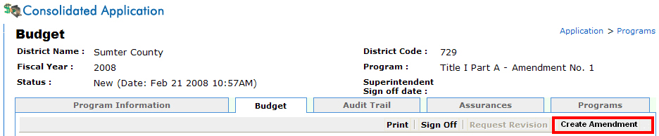
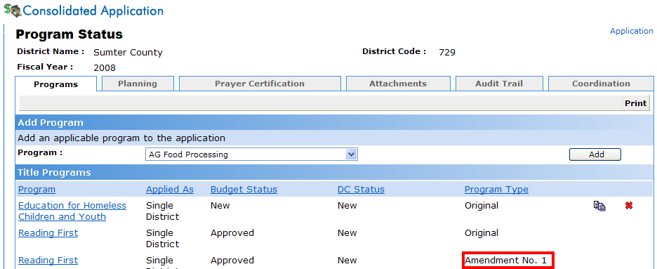
Amendment No. 1

Editing Amendments
8
Step

(Optional)
Once the Consolidated Application Coordinator creates the amendment, the Consolidated Application Coordinator would return to step 3 to complete the program data for the amendment to log into the application.
The Superintendent, State Program Manager, and State Grants Accounting will sign-off just like they did in the original program.
Responsible Roles:
- LEA Consolidated Application Coordinator
- Superintendent
- State Program Manager
- State Consolidated Applications Coordinator
- State Plan Approver
- State Grants Accounting

Performing Queries
Three queries are available within the Consolidated Application Status, Title I-A School Allocation, and Budget Comparison.
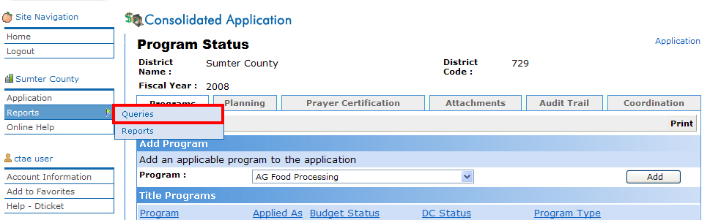

Application Status Query
- Click Reports > Queries on the far left-hand of the screen.
- Select the Application Status Queries.
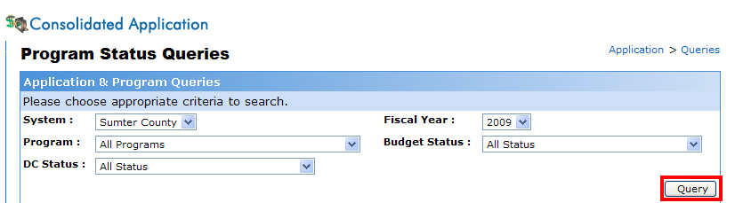
- Select the appropriate options from the drop-down menus and select the Query button.

Title I-A School Allocation Query
- Click Queries on the far right-hand of the screen.
- Select Title I-A School Allocation Queries.
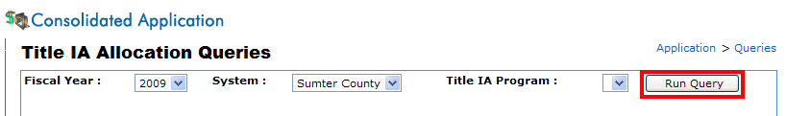
- Select the appropriate options from the drop-down menus and select the Run Query button.

Budget Comparison Query
- Click Queries on the far right-hand of the screen.
- Select Budget Comparison Queries.
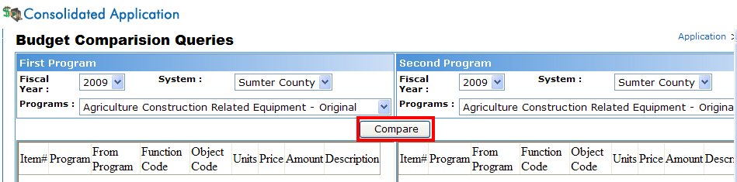
- Select the appropriate options from the drop-down menus and select the Compare button.
Running Reports
Five reports are available within the LEA Consolidated Application: Application Summary, Program Summary, Budget Summary, Budget Transferability, and Unbudgeted Funds.
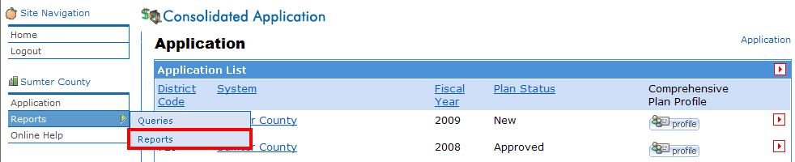

Application Summary Report
- Click Reports on the far left-hand of the screen.
- A list of the reports appears inside the Reports screen.
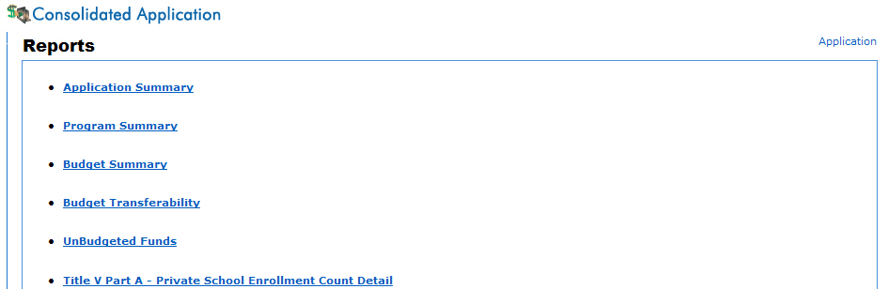
- Select Application Summary.
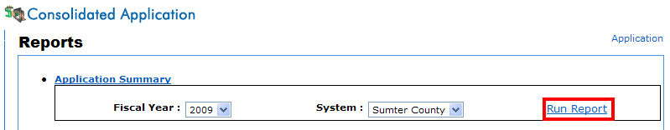
- Click the Run Report link.

Program Summary Report
- Select Program Summary from the list on the Reports screen.
- Select the appropriate options from the drop-down menus and click the Run Report link.

Budget Summary Report
- Select Budget Summary from the list on the Reports screen.
- Select the appropriate options from the drop-down menus and select the Run Report button.

Budget Transferability Report
- Select Budget Transferability from the list on the Reports screen.
- Select the appropriate options from the drop-down menus and select the Run Report button.

Unbudgeted Funds Report
- Select Unbudgeted Funds from the list on the Reports screen.
- Select the appropriate options from the drop-down menus and select the Run Report button.
Questions?

Technical Questions
If you experience problems within the application, please contact the helpdesk at dticket@doe.k12.ga.us. For individual program information please see our contact list on the next page.

Program-Specific Questions
Program-Specific names, phone numbers, and e-mail addresses can also be found at the following link: LEA Consolidated Application by selecting Guidance & Contact List.

