CAREER, TECHNICAL AND AGRICULTURE EDUCATION

Lab Layouts

School Year 2009-2010

Agriscience Lab | Architectural Drawing & Design Lab | Automotive Service Technology Lab | Aviation Lab
Broadcast & Video Lab | Business & Computer Science Lab | Construction Technology Lab | Cosmetology Lab
Culinary Arts Lab | Early Childhood Education Lab | Engineering, Drawing & Design Lab | Family & Consumer Science Lab
Graphic Communication Lab | Healthcare Science Lab | HVACR Lab | High School Technology Lab
Information Technology Lab | JROTC Lab | Machining Technology Lab | Manufacturing Lab
Marketing Lab | Metals Lab | Middle School Business & Computer Science Lab | Middle School Family & Consumer Science Lab
Middle School Technology Lab | Visual Communication Design Lab | Work Based Learning Lab

Press down on Control (CTRL) key and move mouse over lab layout you prefer to view.

Georgia Department of Education
Career, Technical and Agricultural Education
1752 Twin Towers East
Atlanta, Georgia 30334

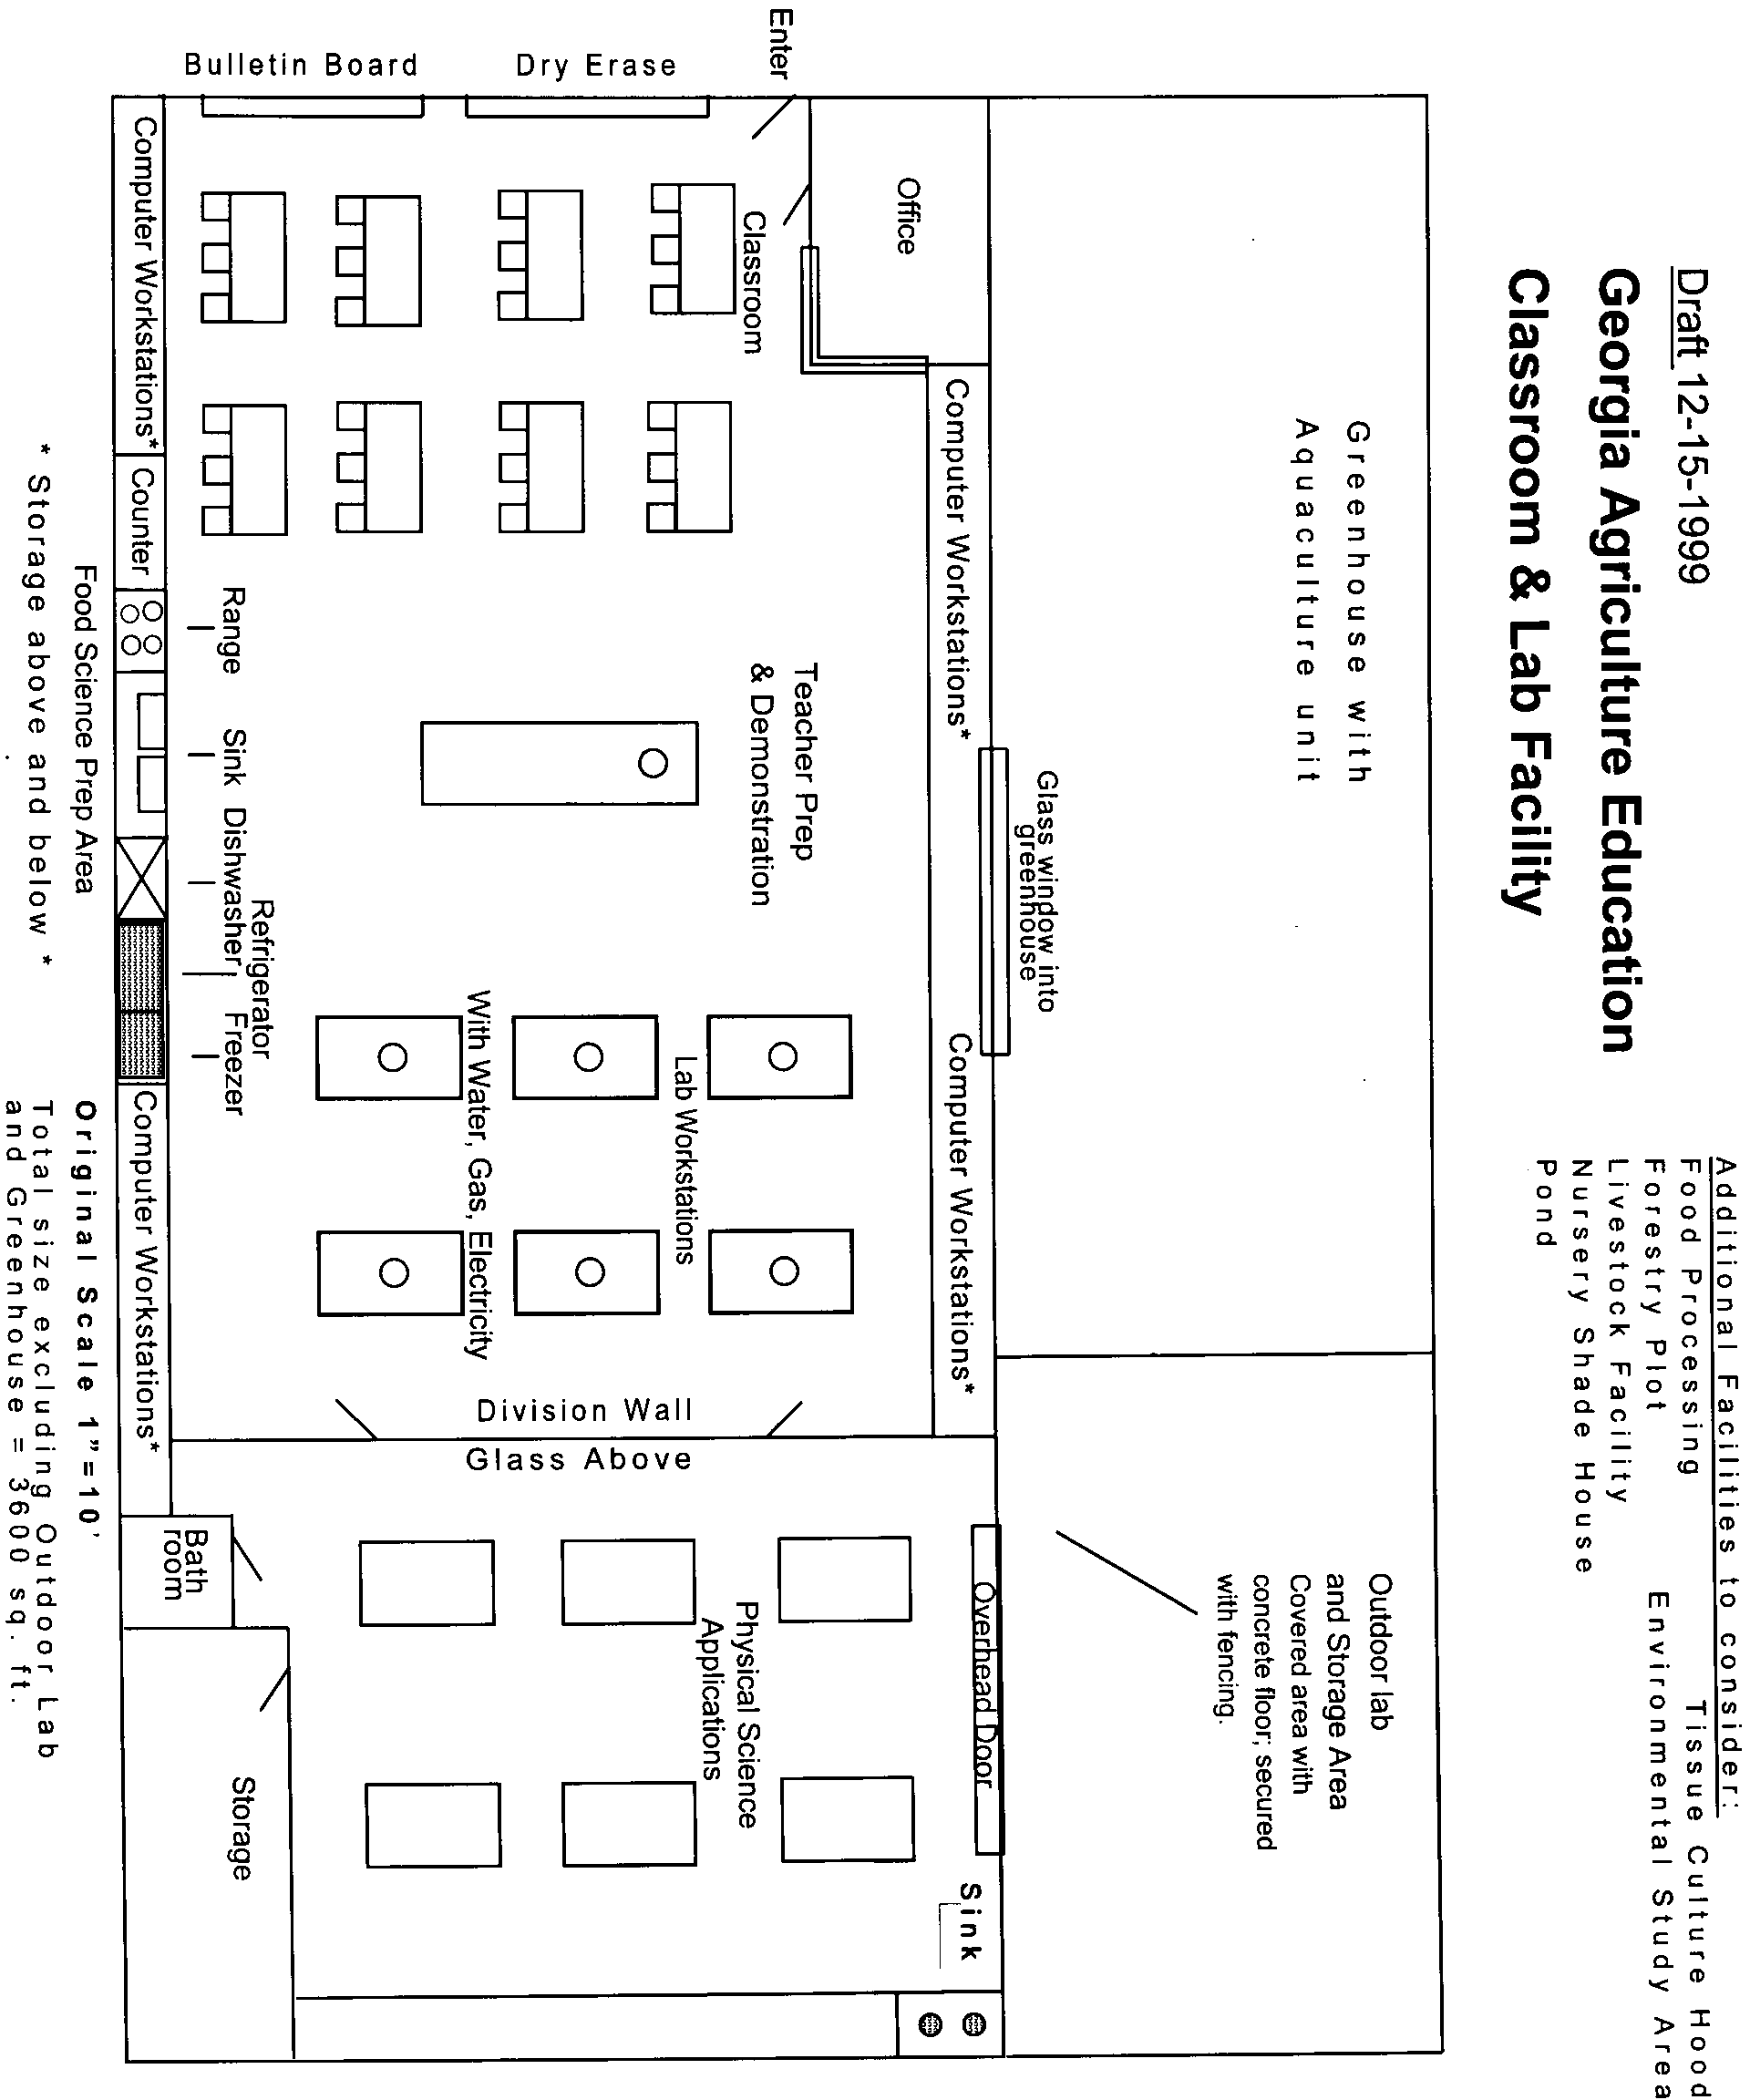
Click here to go Top of Document
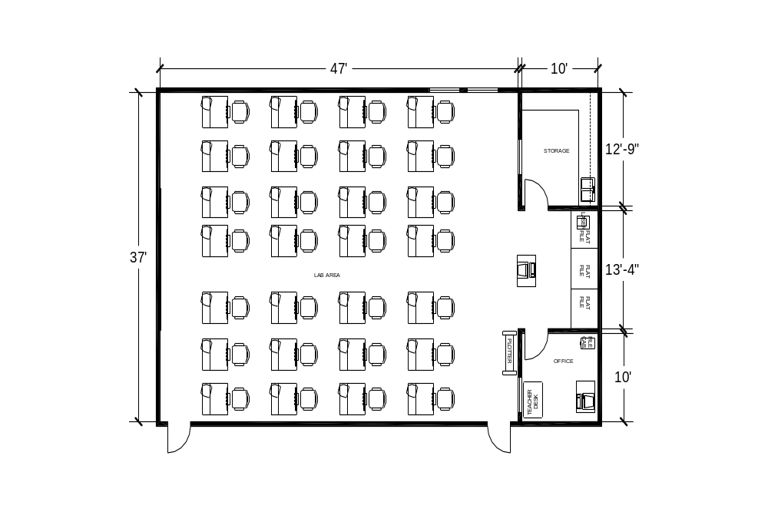
Architectural Drawing & Design Lab
2100 Square Feet
Click here to go Top of Document
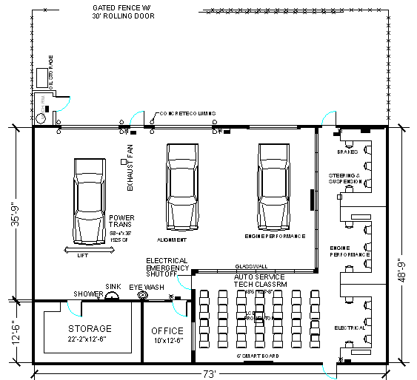

Automotive Service Technology Lab
3365 Square Feet
Click here to go Top of Document
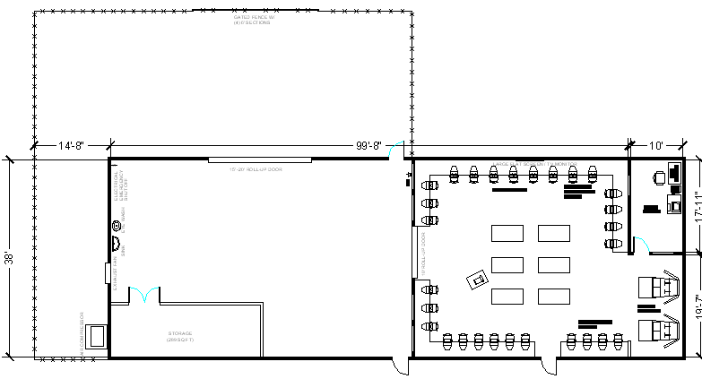
Aviation (Aircraft Support & Flight Operations Lab
4161 Square Feet
Click here to go Top of Document
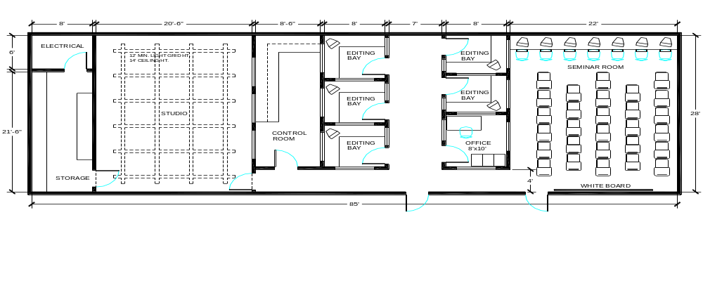
Broadcast Video Production
2400 Square feet

Click here to go Top of Document
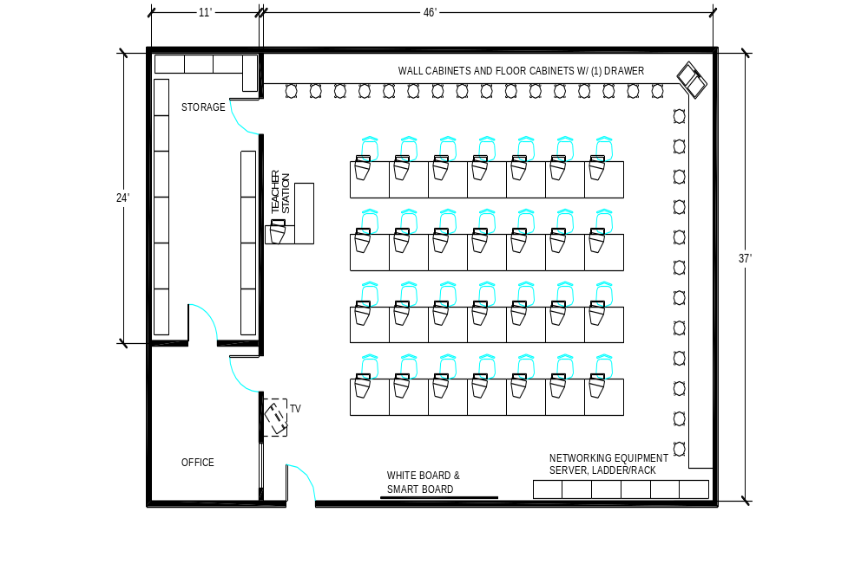
Business & Computer Science
1800 Square feet
Click here to go Top of Document
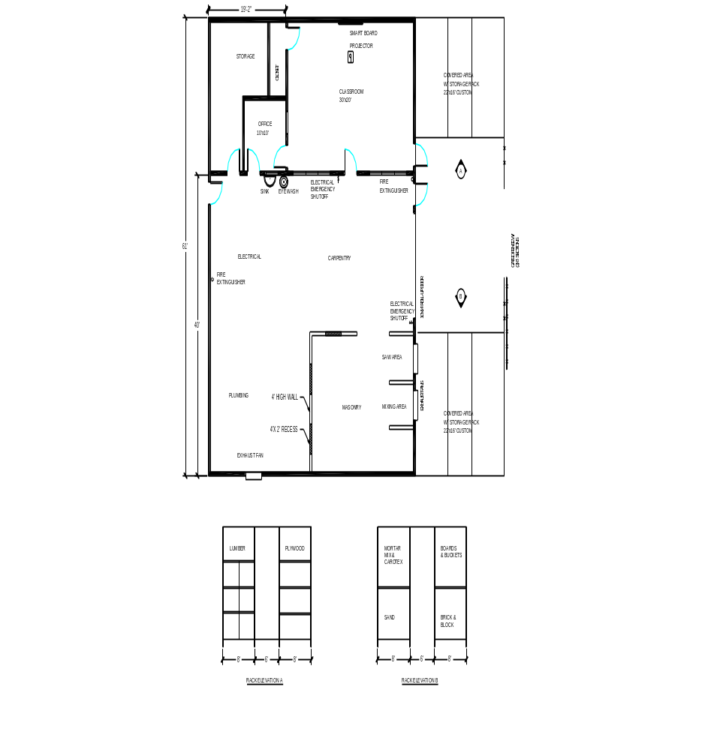

Construction Technology

3000 Square feet
Click here to go Top of Document

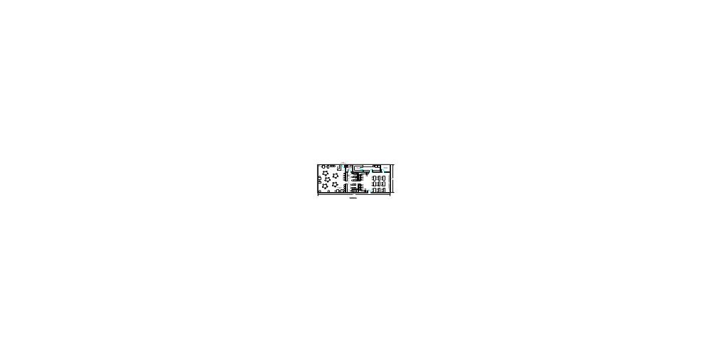 Cosmetology
2400 Square feet

Click here to go Top of Document
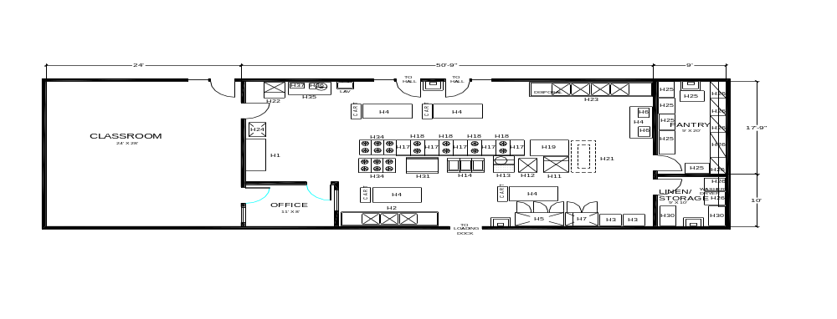
Culinary Arts Lab
2500 Square feet

Click here to go Top of Document
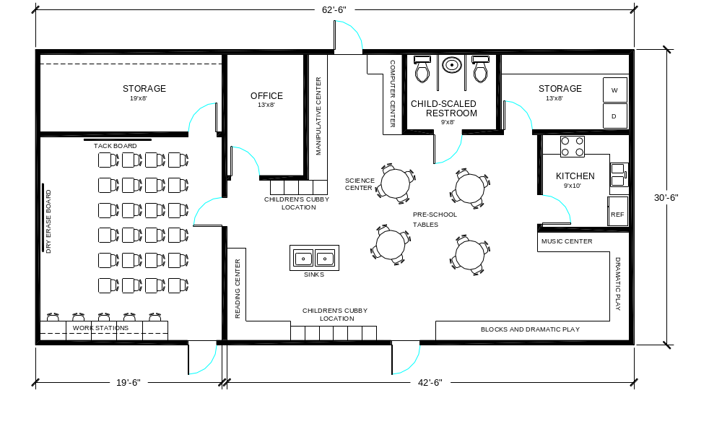Early Childhood Education
1800 Square feet
Click here to go Top of Document
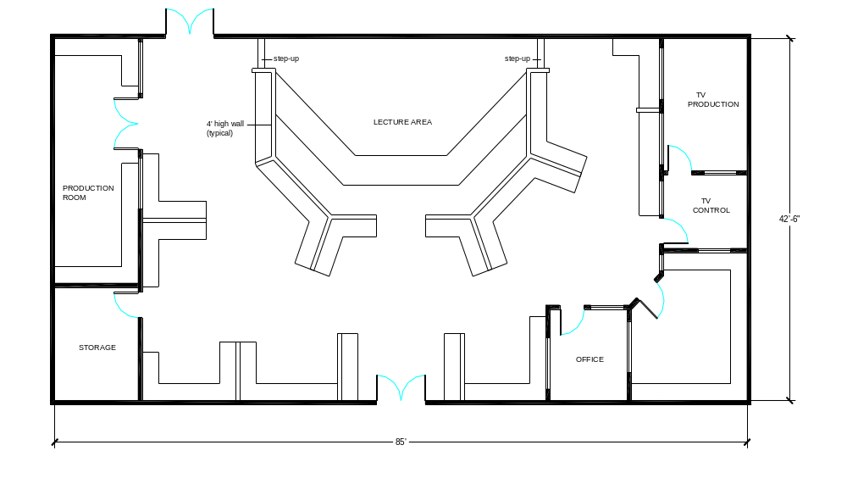
Engineering & Technology Education Lab
3600 Square feet
Click here to go Top of Document

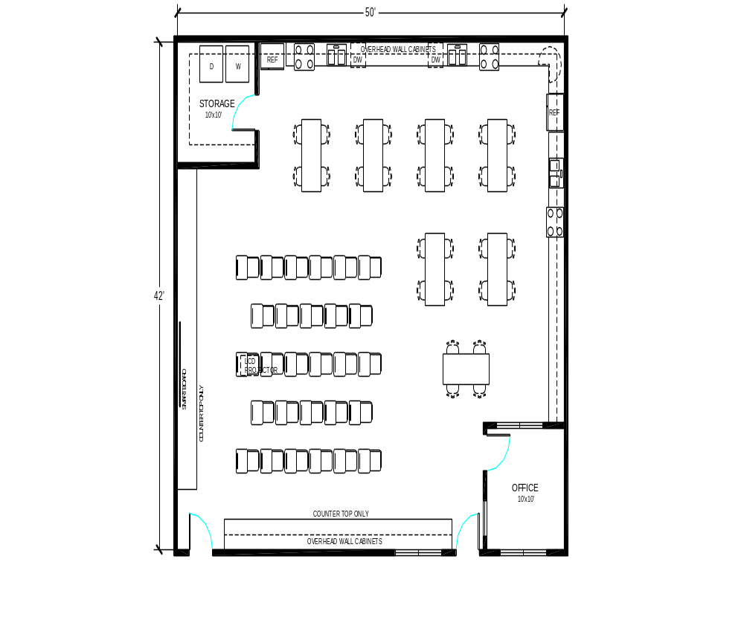
Family & Consumer Sciences Lab
2100 Square feet

Click here to go Top of Document
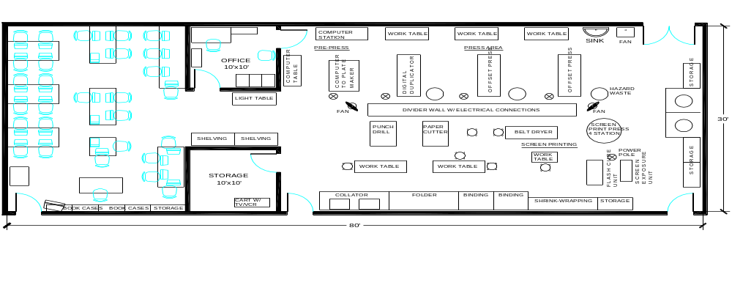

Graphics Communications Printing Technology
2400 Square feet

Click here to go Top of Document
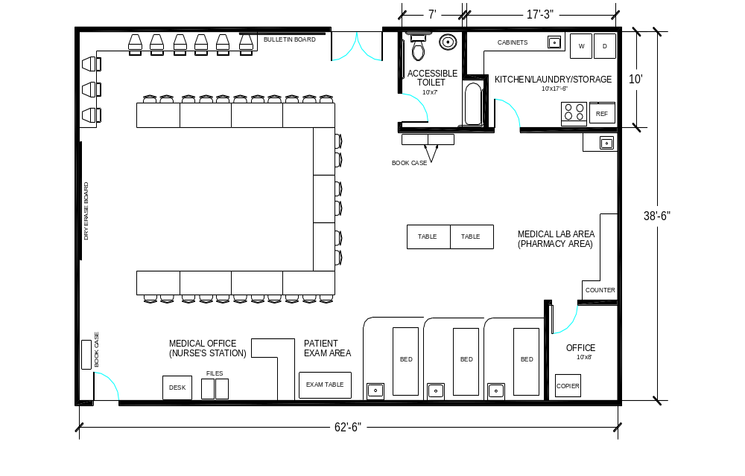
Healthcare Sciences Lab
2400 Square feet
Click here to go Top of Document
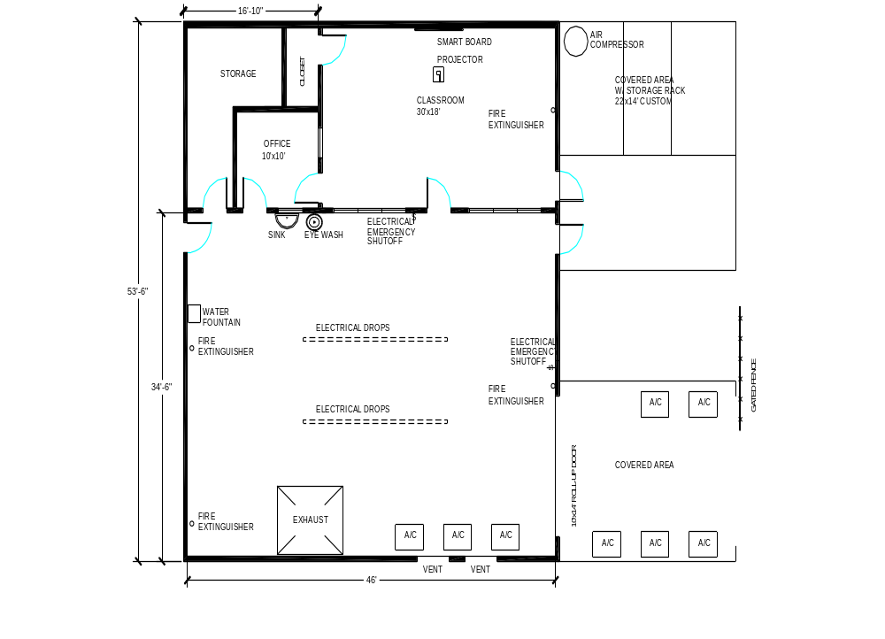
HVACR – Heating, Ventilation, Air Conditioning, Refrigeration
2400 Square feet
Click here to go Top of Document
Information Technology
1800 Square feet
Click here to go Top of Document
JROTC
11,316 Square feet
Click here to go Top of Document
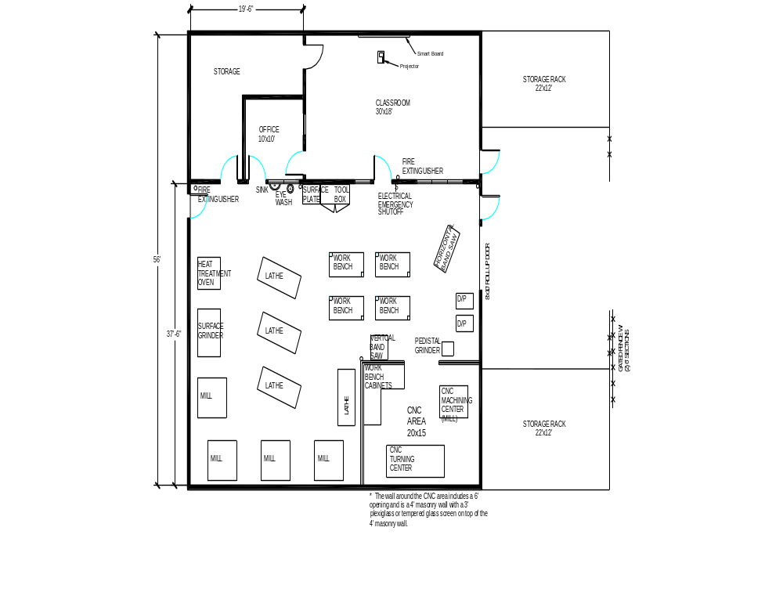
Machining Technology
2800 Square feet
Click here to go Top of Document
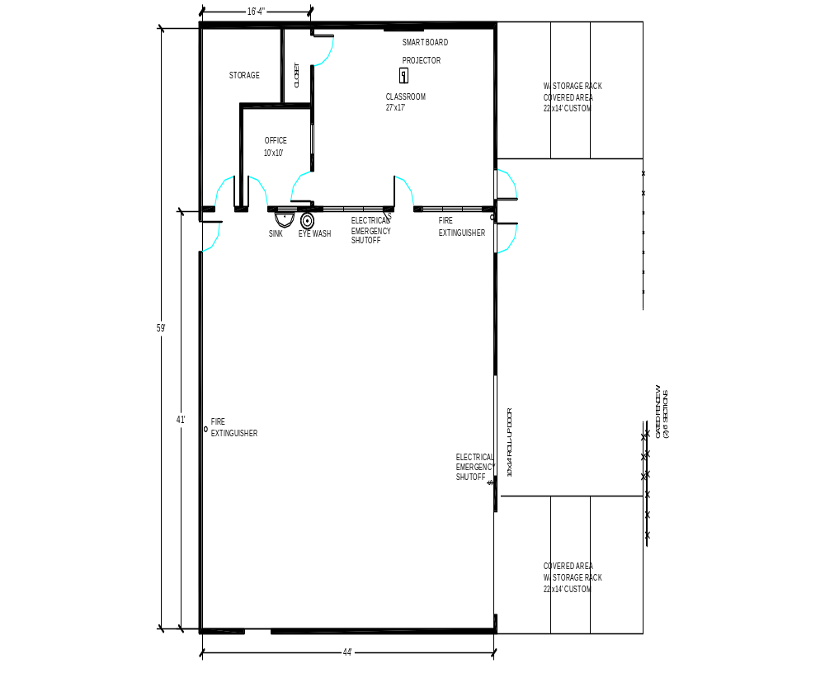
Manufacturing Lab
2600 Square feet
Click here to go Top of Document
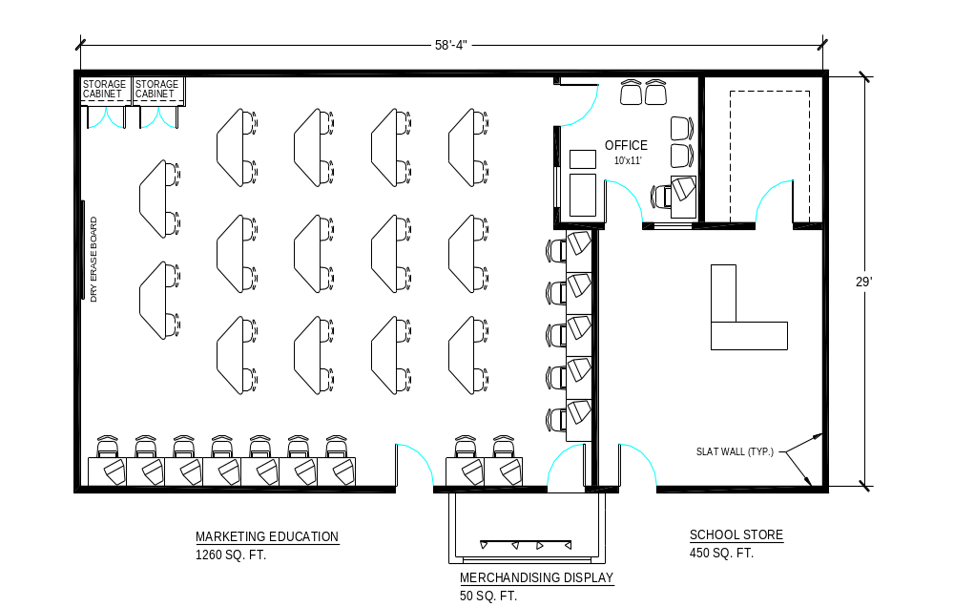

Marketing Education
1800 Square feet
Click here to go Top of Document
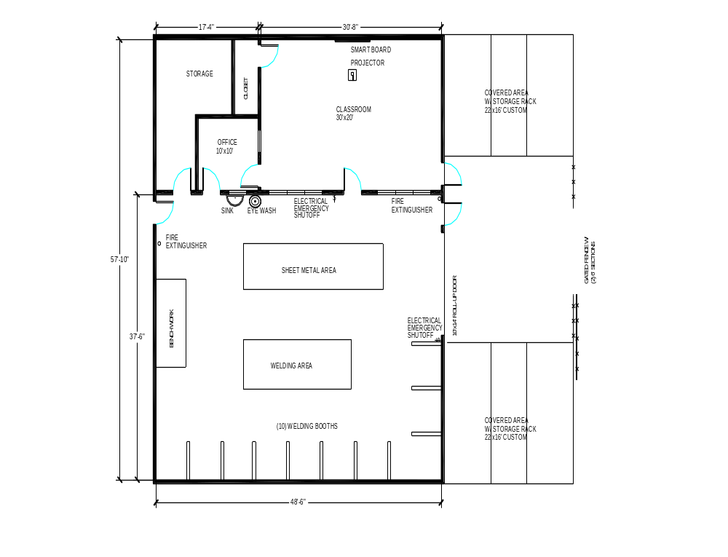
Metals Lab
2800 Square feet
Click here to go Top of Document

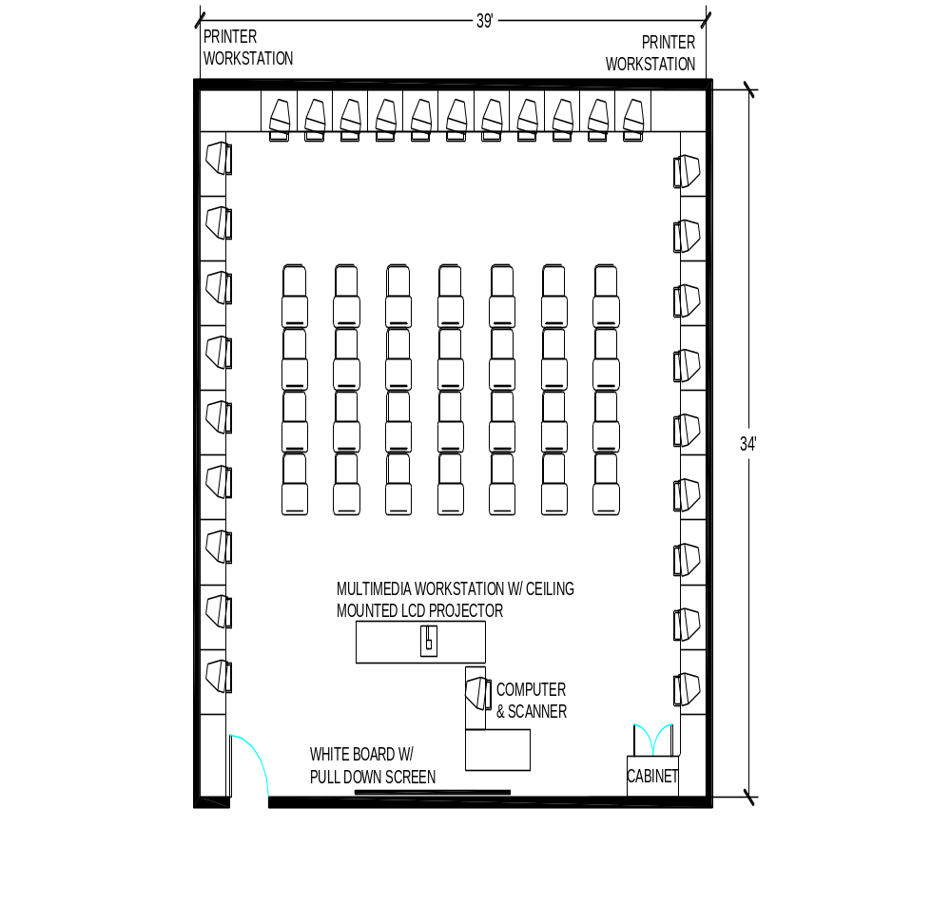Middle School Business Lab
1100 Square feet
Click here to go Top of Document

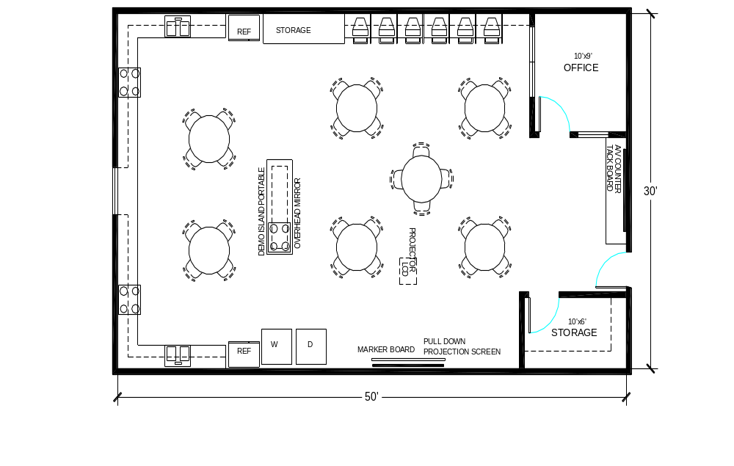

Middle School Family and Consumer Sciences Lab
1300 Square feet
Click here to go Top of Document
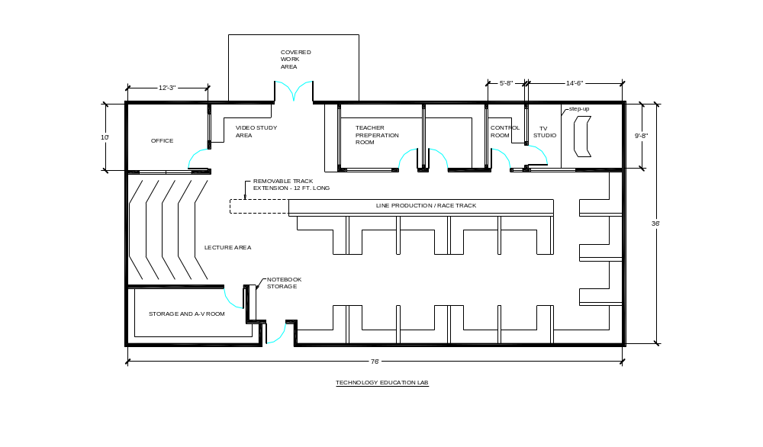
Middle School Technology Education Lab
2300 Square feet
Click here to go Top of Document


Visual Communications and Design
2400 Square feet

Click here to go Top of Document
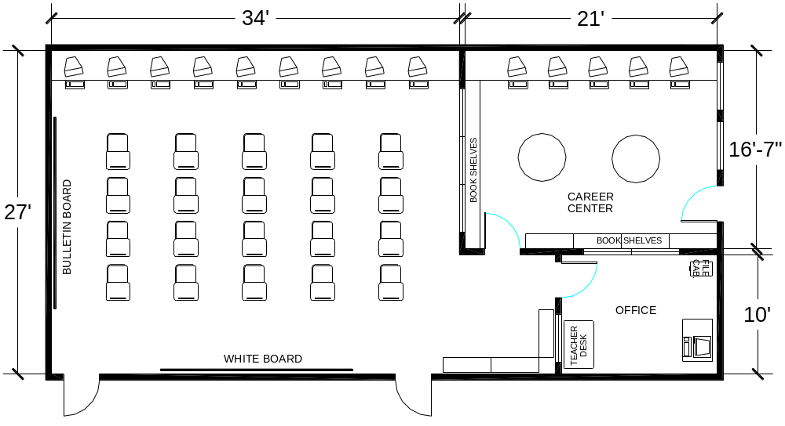
Work Based Learning Skills Lab
1500 Square feet
Click here to go Top of Document

