
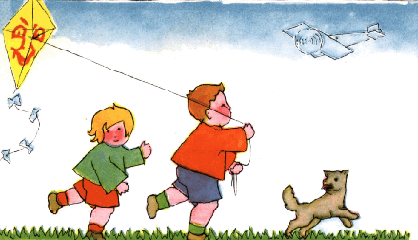
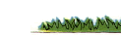
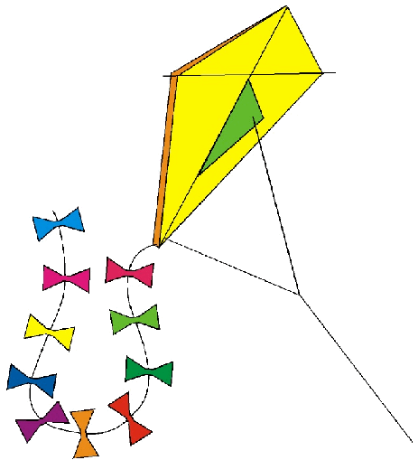


Volume 1 (Click to change text) ( Name) School
March 2011

Reading Rocks!!!
Pick up a book today……..

(Click in any box to change or insert text.)

If you could only sense how important you are to the lives of those you meet how important you can be to the people you never dream of. There is something of yourself that you leave at every meeting with another person. ~ Fred Rogers

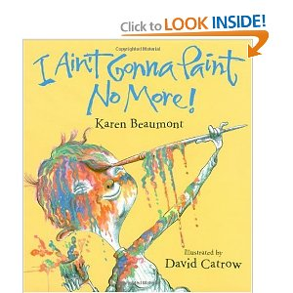



Literary Birthdays
Dr. Seuss March 2
Leo Dillon March 2
Patricia MacLachlan March 3
Suse MacDonald March 3
Meindert DeJong March 4
Dav Pilkey March 4
Mem Fox March 5
Kenneth Grahame March 8
Ezra Jack Keats March 11
Diane Dillon March 13
Marguerite de Angeli March 14
Mitsumasa Anno March 20
Bill Martin, Jr. March 20
David Wisniewski March 21
Randolph Caldecott March 22
Anna Sewell March 30

Winner of the Georgia Children’s Book Award for 2010-2011 is I Ain’t Gonna Paint No More by Karen Beaumont and illustrated by David Catrow.


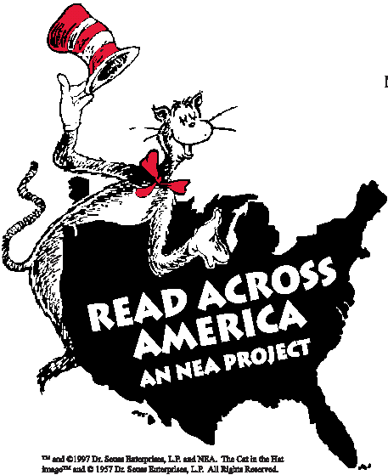
Read a Book, Read a Winner!

The fun of reading isn’t just the book; it’s also in telling your friends about it! This site lets kids give their opinions of books they’ve read so others can find good reading material quickly!
http://www.worldreading.org/

