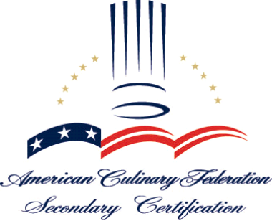

Why Become an ACFF Certified Secondary Culinary Arts Program?

ACFF is the only organization to offer programmatic certification for secondary and vocational culinary arts training programs. ACFF Secondary Certification conveys a high level of professionalism about a program, its faculty, staff, administration, students and graduates to the public and culinary community. The curriculum, faculty, resources and organizational structure of an ACFF Certified Secondary Culinary Arts Program must all unquestionably meet Standards set by the ACFF Secondary Certification Committee.

ACFF Secondary Certification Standards are designed to help schools develop a foodservice-oriented curriculum and assist in providing career objectives for students. These Standards are established and continuously monitored by leaders in the culinary arts industry and the educational community. The Standards encourage and promote ongoing systems for assessing a program's effectiveness, as well as the need for external peer-review to verify program quality.

The ACF publishes a list of certified secondary culinary arts programs to all ACF chapters in the region of the program. Programs are encouraged to build connections with local chapters and promote mentoring and networking opportunities. Members of these chapters can be used as advisory board committee members, guest speakers, demonstrators and various other roles within the program.

Students of certified programs receive Sizzle, the ACF's quarterly publication for students of accredited/certified programs. Each issue of Sizzle predicts the food trends of tomorrow, offers real-life advice on excelling in your new career, reveals tips from successful chefs who've "made it," takes you step-by-step through basic (but Critical) techniques, and introduces the student to exciting, emerging fields in foodservice.

Students graduating from a certified culinary arts program are required to pass a written exam and verify successful completion of an ACF approved sanitation course before becoming eligible to earn the designation of a "Recognized Graduate" of an ACFF Certified Secondary Culinary Arts Program. Graduates will be ready to progress to the next stage in their careers, which may include training toward a college degree at an ACFF accredited post-secondary program or other specialty college, participation in an ACFF apprenticeship program, or placement directly into the industry.

Students are encouraged to use their hours earned (15 points) at graduation toward their first level of ACF professional certification. ACF certification provides an ideal career progression ladder within the foodservice industry. As graduates chart their course, their continued education and hard-won work experience will reward them with greater promotion opportunities and chances to gain higher levels of ACF professional certification.

American Culinary Federation Foundation Secondary Certification
Program Eligibility Criteria

1. The program must be offered at an institution which is legally authorized under applicable state law to provide secondary education and which is institutionally accredited by an agency recognized by the U.S. Department of Education or approved by a comparable government agency.

The following are institutional accrediting agencies: Council on Occupational Education; New England Association of Schools and Colleges; Middle States Association of Colleges and Schools; North Central Association of Colleges and Schools; Northwest Association of Schools and Colleges; Southern Association of Colleges and Schools; Western Association of Schools and Colleges; Accrediting Council for Continuing Education and Training; Accrediting council for Independent Colleges and Schools; Accrediting commission of Career Schools and Colleges of Technology; and New York State Board of Regents. For a program to be eligible for ACF accreditation, it must be offered in an institution accredited by one of the above-mentioned agencies.

2. The program’s application for certification must be authorized by the institution’s Principal, Vocational Director or designee.

3. The program must be secondary/vocational and so authorized under applicable state law or comparable government unit.

Some vocational technical programs have post- secondary enrollment; however, the majority of the students in the program must be enrolled at the secondary level.

4. The program coordinator must have credentials that include:

- a minimum of (2) years industry experience
- a minimum of one industry certification
- a minimum of a AS degree in a related
discipline
- or an equivalent combination with the above
degree

A Bachelors or Master’s degree is preferred. For those who do not meet these requirements at the date of the initial application there must be evidence of a plan in place to achieve these goals within 3 years.

The American Culinary Federation certification program, as well as those offered by other professional hospitality organizations, have published guidelines as to how to become certified. There are requirements including both education (formal and continuing) as well as industry experience which are common to certification programs. Credentials must be at least equivalent to those of an ACF Certified Culinary Educator, ACF Certified Secondary Culinary Educator, Certified Chef de Cuisine, or Certified Working Pastry Chef. Other acceptable professional certifications that satisfy this requirement include Certified Food & Beverage Executive, Certified Hospitality Educator, Certified Master Baker, Certified Hotel Administrator, Registered Dietitian, or Foodservice Management Professional. A Master’s degree in an appropriate discipline is preferred. Appropriate Master’s degrees for the administrator of the program include business, hospitality, food science, education, foodservice management, dietetics, and others related foodservice.

5. The program must have been in continuous existence for a minimum of two years and must have graduated seventy percent of full time students within a three year period in order for the
Committee to judge its educational success.

Part of the self-assessment process includes incorporating feedback from the graduates, placement statistics, and satisfaction studies to help evaluate the success of the program

6. The program must exhibit evidence of meeting the competencies as specified in the ACF Secondary Certification “Required Knowledge and Skill Competencies”.

The “Required Knowledge and Competencies” consist of 11 knowledge areas (12 for Baking or Pastry programs) which not all require separate courses in order to satisfy this requirement. However the Committee will determine if the hours allotted to each objective is adequate for student competence.

7. The culinary/foodservice program must be designed to include both hands on and theoretical culinary instruction. The program must meet state requirements for contact hours covering both theoretical instruction and the required skill standards. Laboratory instruction or work based learning would make up the remainder of the required contact time (No fewer than 360 hours).

If work based learning is included, this may be counted on a ratio of 10 hours of work=1 contact hour, as long as the work experience is monitored by school personnel and provides evidence that the objectives of the programs are met, formal agreements must be in place.

When counting contact hours, include those required for general education courses and work requirements. Fifty-minute classes count as one contact hour. However, work-study experiences are counted at the rate of 10:1.

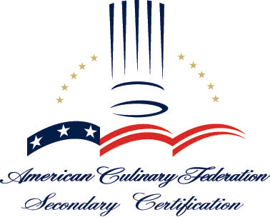

ACFF Secondary Certification: Fostering Future Culinarians

Culinary arts education is now one of the most popular programs of choice for students across the country. The expanding hospitality industry continues to provide an increasing job market for individuals who have been trained in the field. To meet the need for trained individuals, high schools, vocational technical centers, colleges, and universities have all created large numbers of programs in culinary arts, foodservice management, and dozens of other program titles. Opportunities for developing and maintaining quality educational programs in the culinary field have never been better.

The ACF promotes the professional image of American chefs worldwide through education among culinarians at all levels, from apprentices to the most accomplished certified master chefs. The ACF has a long tradition of ensuring quality education for the culinary arts and foodservice professions. In 1984 the ACFF Accrediting Commission (ACFFAC) was created to provide quality assurance and oversee accreditation of culinary arts programs.

There are five sub-committees of the ACFF Accrediting Commission, including the ACFF Secondary Certification Committee. The primary function of the ACFF Secondary Certification Committee is to provide programmatic certification for secondary and vocational culinary arts programs. This certification is a voluntary action on the part of the institution and requires that curriculum, faculty, resources, support staff, and organizational structures, all meet quality Standards.

The ACFF Secondary Certification Standards are designed to help schools develop a foodservice-oriented curriculum and assist in providing career objectives for students. The Standards are dynamic and as the industry changes, new requirements are added and some deleted. Graduates of certified programs will be ready to progress to the next stage in their careers, which may include training toward a college degree at an ACFF accredited post-secondary program or other specialty college, participation in an ACF apprenticeship program, or placement directly into the industry.

Programs begin the certification process by requesting the Initial Application from the ACF. The form can be obtained from the ACF website at www.acfchefs.org under the downloads section or by calling the ACF at 1-800-624-9458.

* To receive the Policies and Procedures of the secondary certification process, Required Knowledge and Skills Competencies, and certification Initial Application, a non-refundable fee of $75.00 will be required.

Frequently Asked Questions

Question: What is the first step in the process?
Answer: Request the complete informational package from the ACF National
Office, which includes the Application for Consideration of Initial Grant of
Certification. Complete the application and submit it along with the required documentation to the ACF Office of Secondary Certification at 180 Center Place Way, St. Augustine, FL 32095.

Question: What happens after the application is returned?
Answer: Your program will be notified as to its eligibility within 30 days of
receipt of the application.

Question: What happens after the application is approved?
answer: Your program will be sent the self-study template and instructions on
how to complete the self-study.

Question: What happens after the self-study is completed?
Answer: The completed self-study must be forwarded to Office of Secondary
Certification for review. Your program will be contacted if additional documentation is needed. After the self-study has been approved, you will be contacted by the Secondary Certification Coordinator to schedule your Site Visit. Upon confirming dates, the program will work closely with the Secondary Certification Coordinator to coordinate all arrangements for the site visit.

Question: What happens on the site visit?
Answer: An evaluation team spends 1-2 days at your program measuring the
program against Certification Standards and the self-study.
Evaluators must observe lab and classroom activity. Students, faculty, administrators and advisory board members must be available to speak with. The evaluation team will form a team report for review by the
Committee.

Question: What happens after the site visit?
Answer: Your program will submit a response to any Areas of Non-
Compliance (if applicable). Your program’s response, team report and self-study will be reviewed by the Committee during one of its two yearly meetings (January and July).

Question: What happens after the final review?
Answer: The program is notified of the Committee’s decision on a Grant of
Secondary Certification.

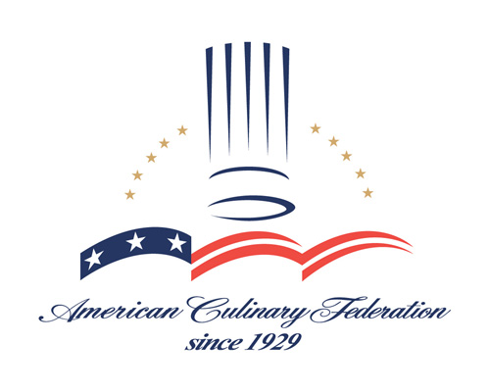

Culinarian’s Code

I pledge my professional knowledge and skill to the advancement of our profession and to pass it on to those that are to follow.

I shall foster a spirit of courteous consideration and congenial cooperation within our profession.

I shall place honor and the standing of our profession before personal advantage.

I shall not use unfair means to effect my professional advancement or to injure the chances of another colleague to secure and hold employment.

I shall be fair, courteous and considerate in my dealing with fellow colleagues.

I shall conduct any necessary comment on, or criticism of, the work of fellow colleagues with careful regard for the good name and dignity of the culinary profession and will scrupulously refrain from criticism to gain personal advantages.

I shall never expect anyone to subject themselves to risks which I would not be willing to assume myself.

I shall help to protect all members against one another from within our profession.

I shall be just and enthusiastic about the success of others as I am about my own.

I shall be too big to worry, too noble for anger, too strong for fear, and too happy to permit the pressure of business to hurt anyone, within or without the profession.
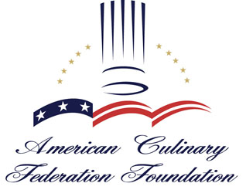 Benefits of Becoming an ACFF Certified Secondary Culinary Arts Program….

- Conveys a high level of professionalism about a program, its faculty, staff, administration, students and graduates to the public and culinary community

- Encourages the promotion of educational standards, which are established by industry leaders in both culinary arts and culinary arts education

- Standards are monitored by the American Culinary Federation Secondary Accrediting Committee

- Encourages and promotes ongoing systems for assessing a program’s effectiveness

- Provides external peer review to verify program quality

- Allows programs to facilitate articulation agreements with post-secondary institutions and programs

- Ensures that the faculty and staff of the program are academically and professionally qualified and have preparation relevant to their areas of responsibility

- Assures students and potential students that a program meets or exceeds national standards set for culinary arts programs nationally

- Increases students knowledge about current industry practices

- Encourages mentoring for students and networking opportunities in the industry regionally and nationally

- Students receive Sizzle, the ACF’s quarterly publication for students of Certified Secondary programs

- Students are required to pass a written examination administered through NOCTI and verify successful completion of an approved sanitation course to become Secondary Culinary Graduates

- Students are prepared for post-secondary training towards a college degree, participation in an ACF apprenticeship program, or placement in the industry

- Students are encouraged to use their hours earned (15 points) at graduation toward ACF professional certification

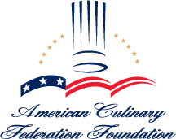

SECONDARY CERTIFICATION

Fee Schedule

APPLICATION PACKET $ 75

NEW PROGRAM APPLICATION $325

INITIAL SELF-STUDY REVIEW $600

RENEWAL SELF-STUDY REVIEW $550

FEE FOR LATE SUBMISSIONS (Effective January 1, 2007) $250

LATE FEES

Late Fees will be assessed for late submissions of an Annual Report, Self-Study, Annual Fees, and any other Commission related submissions with deadlines.

ANNUAL FEES

An Annual Fee of $200 must be submitted with the program Annual Report by May 31.

SITE VISIT FEES

Site visit expenses for team evaluators and ACFFAC evaluation staff will be paid for by the institution.

All fees are non-refundable. Per ACF policy, purchase orders are not accepted as a form of payment. Payment must be received in the form of check, credit card or money order. If your accounts payable department requires an invoice before payment is issued, please contact the office at (800) 624-9458, extension 109

