


Volume 1 (Click to change text) (Name) School September 2011

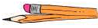


Banned Book Week
Celebrate your freedom to read during Banned Book Week. Check out the banned and challenged book lists here to find a way to celebrate your freedom.

YALSA’s Teens’ Top Ten
Continued from last month
- Fitzpatrick, Becca. Crescendo.
- Grant, Michael. Lies.
- Hawkins, Rachel. Demonglass.
- Hakwins, Rachel. Hex Hall
- Kagawa, Julie. The Iron King.
- Lore, Pittacus. I Am Number Four.
- Moore, Peter. Red Moon Rising.
- Nelson, Jandy. The Sky is Everywhere.
- Oliver, Lauren. Before I Fall.
- O’Neal, Ellis. The False Princess.
- Patterson, James. Angel: A Maximum Ride Novel..
- Pearce, Jackson. Sisters Red.
- Smith, Cynthia Leitich. Blessed.
- Westerfeld, Scott. Behemoth.
- White, Kiersten. Paranormalcy.



Literary Birthdays: *
Eugene Field September 2

Richard Wright September 4
Leo Tolstoy September 9

O Henry September 11

Mildred Taylor……… September 13

William Carlos Williams September 17

H.G. Wells… September 21

F. Scott Fitzgerald September 24

William Faulkner September 25
T.S. Eliot September 26

Miguel de Cervantes September 29

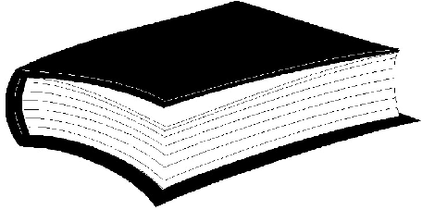
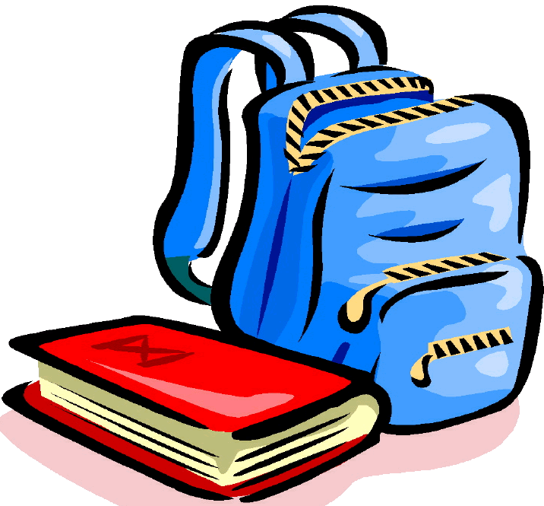

What’s Happening in our school?



Have you tried? 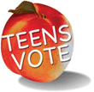
Georgia Peach Award for Teen Readers
The purpose of the Georgia Peach Award is to highlight and promote the best current young adult literature for Georgia high school age students, to encourage young adults to read and to promote the development of cooperative school and public library services for young adults. Teens vote for their favorite books out of the year's top 20 nominees at their high schools and local public libraries.

Beautiful Creatures by Kami Garcia and Margaret Stohl In a small South Carolina town, where it seems little has changed since the Civil War, sixteen year old Ethan is powerfully drawn to Lena, a new classmate with whom he shares a psychic connection and whose family hides a dark secret that may be revealed on her 16th birthday.

