Parental Overview Document of FITNESSGRAM Assessment in Georgia

The FITNESSGRAM Reference Guide is intended to provide answers to some common questions with the use and interpretation on the FITNESSGRAM assessment. The purpose of this document is to provide a general overview of the assessment administration and interpretation of the scores for parents and other interested parties. This document is organized into some of the common questions associated with this topic.

- What is FITNESSGRAM?
- What is the philosophy of FITNESSGRAM?
- What is the Healthy Fitness Zone?
- What are the assessments?

- Why is aerobic capacity important?
- The PACER or the One-Mile Run

- Why is body composition important?
- Height/Weight

- Why is muscular strength, endurance and flexibility important?
- Curl-Up
- Push-Up
- Back-Saver Sit and Reach

- Sample FITNESSGRAM Report
- How can I help my child be more fit and active?
- Frequently Asked Questions
- Why is assessing fitness important to my child?
- Can my child “fail” the FITNESSGRAM assessment?
- Will my child’s scores be posted or be made public?
- Will my child’s results be compared to other students?
- What are the FITNESSGRAM assessment items?
- What can my child do to prepare for the fitness assessment?
What is FITNESSGRAM?

FITNESSGRAM is the national fitness assessment and reporting program for youth. The assessment was developed by The Cooper Institute in response to the needs in physical education programs for a comprehensive assessment protocol. The assessment includes a variety of health-related physical fitness assessments designed to assess cardiovascular fitness, muscle strength, muscular endurance, flexibility, and body composition. Criterion-referenced standards associated with good health have been established for children and youth for each of the health-related fitness components. The software for the program produces an individualized report card that summarized the child’s performance on each component of health-related fitness and provides suggestions for how to promote and maintain good fitness. The sophisticated database structure within the program produces compiled class reports and allows for long-term tracking of the student’s fitness over time. FITNESSGRAM can be used by students to help them in personal fitness programming, by teachers to determine student needs and to help guide students in program planning, and by parents to understand their child’s needs and to help the child plan a program of physical activity.

What is the philosophy of FITNESSGRAM?

H = Health and health-related fitness
The primary goal of FITNESSGRAM is to promote regular physical activity among all youth. Of particular importance is promoting activity patterns that lead to reduced health risk and improved health-related physical fitness.

E=Everyone
FITNESSGRAM is designed for all people regardless of physical ability. It is intended to help ALL youth find some form of activity that they can do for a lifetime. Too often activity programs are perceived to be only for those who are “good” rather than for all people.

L=Lifetime
FITNESSGRAM has as a goal helping young people to be active now, but a long term goal is to help them learn to do activities that they will continue to perform throughout their lives.

P=Personal
No two people are exactly the same. No two people enjoy the exact same activities. FITNESSGRAM is designed to personalize physical activity to meet personal or individual needs.

What are the goals of FITNESSGRAM?

The specific program goals of FITNESSGRAM are to promote enjoyable regular physical activity and to provide comprehensive physical fitness and activity assessments and reporting programs for children and youth. The program seeks to develop affective, cognitive, and behavioral components related to participation in regular physical activity in all children and youth, regardless of gender, age, disability, or any other factor. We believe that regular physical activity contributes to good health, function, and well-being and is important throughout a person’s lifetime. The use of FITNESSGRAM as part of a quality physical education program can help in accomplishing these goals.

What is the Healthy Fitness Zone?

FITNESSGRAM uses criterion-referenced standards to evaluate fitness performance. These standards have been established to represent a level of fitness that offers some degree of protection against diseases that result from sedentary living. Performance is classified in two general areas: “Healthy Fitness Zone” (HFZ) and “Needs Improvement.”

As stated above, a score in the HFZ represents the level of fitness thought to provide some protection from the potential health risks that result from a lack of fitness in the measure. The beginning of the HFZ represents a minimum level of fitness necessary to have acceptable health. These standards reflect reasonable levels of fitness that can be attained by most children that participate regularly in various types of physical activity. Because of this, we recommend that all students should strive to achieve a score that places them inside the HFZ. It is not uncommon for children to achieve the HFZ for some dimensions of fitness but not for others. Most children usually have areas that they excel in more than others.

The category below the HFZ is referred to as “Needs Improvement” to indicate dimensions of fitness that may require special attention. While the effect of low fitness may not influence health until later in adulthood it is important to identify potential risks early on so that adjustments can be made to improve those levels. Therefore, the Needs Improvement message should be used prescriptively to help children set goals or targets to improve their fitness. The wording used for this category does not imply “bad fitness” or “poor fitness” but rather areas in which the child should seek improvement.

The aerobic fitness standards establish three zones based on potential risks for future health problems. The Healthy Fitness Zone was established by determining the level of aerobic fitness required for a low risk for future health problems. The Needs Improvement – High Risk zone defines levels of aerobic fitness that indicate potential health risks (current or future risks). Youth between the two zones are classified in an intermediate zone referred to as Needs Improvement – Some Risk.

It should be noted that it is also possible for some students to score above the HFZ. FITNESSGRAM acknowledges performances above the HFZ but does not recommend this level of performance as an appropriate goal level for all students. However, students who desire to achieve a high level of athletic performance may need to consider setting goals beyond the HFZ.

From a similar perspective, aerobic capacity standards are not presented for students in grades K-3. This is partly because of the challenges associated with determining standards but also a philosophical decision by the Scientific Advisory Board. Performance levels are not the most important objective for young children in this age range. Instead, the emphasis for young children should be on enjoying activity and on learning to perform the assessment items successfully.

What are the assessments?

- Aerobic Capacity – The PACER or the One-Mile Run
- Body Composition – Height/Weight
- Abdominal Strength – Curl-Up
- Upper Body Strength – Push-Up
- Flexibility – Back-Saver Sit and Reach

Why is aerobic capacity important?

Aerobic capacity is perhaps the most important area of any fitness program. Research clearly indicates that acceptable levels of aerobic capacity are associated with a reduced risk of high blood pressure, coronary heart disease, obesity, diabetes, some forms of cancer, and other health problems in adults. The evidence documenting the health benefits of physical activity has been summarized most concisely in Physical Activity and Health: A Report of the Surgeon General (U.S. Department of Health and Human Services, 1996), available online at www.cdc.gov/nccdphp/sgr/sgr.htm.

Many terms have been used to describe this dimension of physical fitness, including cardiovascular fitness, cardiorespiratory fitness, cardiorespiratory endurance, aerobic fitness, aerobic work capacity, and physical working capacity. Although defined somewhat differently, these terms can generally be considered synonymous with aerobic capacity.

Aerobic capacity indicates how well your body uses oxygen. It tells you how well you would do running, cycling, or playing sports at a high level.

Aerobic capacity relative to body weight (maximal oxygen uptake, VO2max) is considered to be the best indicator of a person’s overall cardiorespiratory capacity. VO2max is mathematically estimated from the student’s performance on the PACER assessment.

The PACER
Assessment Administration
The PACER (Progressive Aerobic Cardiovascular Endurance Run) uses a recorded pace and the student runs back and forth between two points that are 20 meters apart (a 15 meter version is available for elementary schools with smaller gymnasiums). The objective is to get from one point to the other before the recorded “beep” sounds. The recording of beeps also has music in the background. The PACER is progressive in intensity – it starts easy and gradually gets harder. When the student can no longer complete the distance in the time allowed, the assessment ends. The score is the number of completed laps.

Interpreting PACER Results
The PACER score is converted to an estimated VO2max (indicates how efficiently your body uses oxygen). The score will be charted in the Healthy Fitness Zone, Needs Improvement – Some Risk, or Needs Improvement – High Risk.

A low score on the field assessments estimates of aerobic capacity may be influenced by many factors. These include:
- Actual aerobic capacity level
- Body composition
- Running/walking efficiency and economy
- Motivation level during the actual assessment experience
- Extreme environmental conditions
- Ability to pace
- Innate ability

Improvement in any of these factors may improve the assessment score. Aerobic capacity can be improved substantially in an unconditioned person who participates regularly in sustained activities involving large muscle groups. The amount of improvement is related to the beginning level of fitness and to the intensity, duration, and frequency of the training.

The One-Mile Run

Assessment Administration
The One-Mile Run/Walk has been used for many years as a field test of aerobic capacity. For students who enjoy running and are highly motivated, it is a very good assessment. The objective of the test is to run one mile as fast as possible. Walking is permitted if necessary. The score on the test is the length of time in minutes and seconds.

Interpreting the One-Mile Run/Walk Results
The One-Mile Run/Walk score is converted to an estimated VO2max (indicates how efficiently your body uses oxygen). The score will be charted in the Needs Improvement area or within the Healthy Fitness Zone area of the graph.

A low score on the field test estimates of aerobic capacity may be influenced by many factors.
These include:
- Actual aerobic capacity level
- Body composition
- Running/walking efficiency and economy
- Motivation level during the actual testing experience
- Extreme environmental conditions
- Ability to pace on the one mile run/walk
- Innate ability

Improvement in any of these factors may improve the test score. Aerobic capacity can be improved substantially in an unconditioned person who participates regularly in sustained activities involving large muscle groups. The amount of improvement is related to the beginning level of fitness and to the intensity, duration, and frequency of the training.

Why is body composition important?

The prevalence of overweight and obesity has increased sharply in recent years, and the trends are evident for children as well as adults. These trends have been associated with the low cost and availability of high-fat foods, as well as with declining levels of physical activity in the population. High levels of body fatness are associated with increased risk of coronary heart disease, stroke, and diabetes. While children are not generally at risk for heart disease or stroke, increases in blood pressure and cholesterol occur in overweight and obese children. In addition diabetes (type 2) has increasingly been diagnosed among children, even though this condition has generally been viewed as “adult-onset” diabetes. Obesity and heart disease risk factors are known to track through the life span, so it is important to document body composition as part of a comprehensive health-related fitness profile. Like other dimensions of health-related fitness, body composition does affect health status (even in childhood) and does improve with regular participation in physical activity.

Your child’s body composition will be assessed with Body Mass Index (BMI) which is based on height and weight.

Height/Weight – Body Mass Index

Assessment Administration
Body Mass Index (BMI) is calculated from a measurement of the height and weight. These numbers are entered into the software and the BMI is calculated. Body Mass Index provides an indication of the appropriateness of the weight for the height.

Interpreting Body Composition Results
Scores that fall either below or above this zone should receive attention, for these students have greater potential than others to develop health problems related to their level of fatness or leanness.

The body composition standards establish three zones based on potential risks for future health problems. The Healthy Fitness Zone was established by determining body fat values that indicate a low risk for potential health problems. Ideally, students should strive to be within the HFZ. A score in the Needs Improvement – Some Risk category indicates that the student is either overfat or the student’s weight is too high for his or her height. However, students who are extremely muscular may have a BMI in the Needs Improvement area but may not have excess fat. Students in the Some Risk category should work to move into the HFZ because their level of body composition puts them at some risk of developing health problems. Students in the Needs Improvement – High Risk category must be strongly encouraged to modify their activity and eating behaviors to begin reducing their weight. Students in this High Risk category have a great possibility of developing health problems now and in the future if their body composition does not change.

When interpreting body composition scores, it is important to remember the following:
- Body Mass Index provides an estimate of the appropriateness of the weight for the height.
- Body Mass Index may falsely identify a very muscular lean person as overfat (too heavy for height) or a lightweight person with little muscular development and a large percent of fat as being in the HFZ when the person is actually overfat).

In general, students who score in the Needs Improvement area should be encouraged to work toward the HFZ by slowly changing their body weight through increased physical activity and decreased consumption of high-fat, high-calorie, low-nutritional foods. Changing dietary habits and exercise habits can be very difficult. Students with severe obesity or eating disorders may need professional assistance in their attempts to modify their behaviors. Evidence in adults clearly indicates that participation in regular physical activity moderates the health risks associated with obesity. Because this relationship likely holds for children as well, emphasis for overweight children should be on being physically active and not on absolute weight or fat loss.

It is important to remember when interpreting body composition results that most students who are overfat may also have performances in other assessment areas that are outside the Healthy Fitness Zone. An improvement in body composition will generally result in an improvement in other fitness areas as well.

There is also an area in the body composition graph identified as Very Low. Parents of children who are categorized as very lean should consider factors that may be responsible for the low level of body fat. Many students may naturally be very lean while others may have inappropriate nutritional patterns. Creating awareness of a child’s current status is the primary purpose in identifying lean students. Changes in status should be monitored.

Why are muscular strength, endurance,
and flexibility important?

Assessments of muscular strength, muscular endurance, and flexibility have been combined into one broad fitness category because the primary consideration is determining the health status of the musculoskeletal system (muscles and bones). It is equally important to have strong muscles that can work forcefully and/or over a period of time and also be adequately flexible to allow full range of motion at the joint.

Injuries to bones and joints are many times the result of muscle imbalance at a specific joint; the muscles on one side may be much stronger than the muscles on the other side or may not have adequate flexibility to allow complete motion or sudden motion to occur.

It is important to remember that training to develop muscle strength, endurance, and flexibility is very specific. The movements included in these assessment items are only a sampling of the many ways that the body is required to move and adjust during physical activity.

The upper body and the abdominal/trunk region have been selected as areas for assessment because of their perceived relationship to maintaining functional health and correct posture, thereby reducing possibilities of future low back pain and restrictions in independent living. Although most students will not have weaknesses sufficient to cause current problems, it is important to educate them regarding the importance of muscle strength, endurance, and flexibility in preventing problems as adults. It is especially important to make students aware of correct postural alignment and body mechanics in the event that they are developing scoliosis, which is a problem of teenage youth. The school nurse, a local physician, or a physical therapist are good sources of information related to scoliosis.

The areas being assessed are as follows:
- Abdominal Strength – Curl-Ups
- Upper Body Strength – 90º Push-Ups
- Flexibility – Back-Saver Sit and Reach

The Curl-Up
Assessment Administration
The objective is to do up to 75 curl-ups to a specified cadence (three seconds per repetition). Student lies on the mat on his/her back, knees bent at an angle of approximately 140º, feet flat on the floor, legs slightly apart, arms straight and parallel to the trunk with palms of hands resting on the mat. The fingers are stretched out and the head is in contact with the mat. Student curls up and moves the fingertips from one side of the measuring strip to the other (3.0 inches or 4.5 inches). Head must touch the mat at the end of each curl-up.

Interpreting Curl-Up Scores
Students who score poorly in abdominal strength should be encouraged to participate in calisthenics and other strengthening and stretching activities that will develop the abdominal muscles. However, it is essential to remember that physical fitness training is very specific and that the areas of the body being assessed represent only a fraction of the total body.

To focus on activities that develop the abdominal muscles without equal attention to the trunk extensor muscles will not accomplish the important objective, which is to develop an overall healthy musculoskeletal system. Remember, you must have strength and flexibility (muscle balance) in the muscles on both sides of every joint.

Poor performance on the measures of abdominal strength and trunk extensor strength and flexibility may merit special attention. Gaining strength and flexibility in these areas may help prevent low back pain, which affects millions of people, young and old.

The 90º Push-Up
Assessment Administration
The objective is to do as many push-ups as possible to a specified cadence (three seconds per repetition). The student being assessed assumes a prone position on the mat with hands placed under or slightly wider than the shoulders, fingers stretched out, legs straight and slightly apart, and toes tucked under. The student pushes up off the mat with the arms until arms are straight, keeping the legs and back straight. The back should be kept in a straight line from head to toes throughout the assessment. The student then lowers the body using the arms until the elbows bend at a 90º angle and the upper arms are parallel to the floor. This movement is repeated as many times as possible. The student should push up and continue the movement until the arms are straight on each repetition. The rhythm should be approximately 20 90º push-ups per minute or 1 90º push-up every 3 seconds.

Interpreting Push-Up Scores
Students who score poorly in upper body strength should be encouraged to participate in calisthenics and other strengthening and stretching activities that will develop the muscles in the upper body. However, it is essential to remember that physical fitness training is very specific and that the areas of the body being assessed represent only a fraction of the total body. To focus on activities that develop the muscles that extend the arms without equal attention to the muscles that flex the arms will not accomplish the important objective, which is to develop an overall healthy musculoskeletal system. Remember, you must have strength and flexibility (muscle balance) in the muscles on both sides of every joint. Upper body strength is important for functional health.

The Back-Saver Sit-and-Reach
Assessment Administration
This assessment mainly measures the flexibility of the muscles in the back of the legs. With the one leg straightened, the student reaches as far as possible toward the toes. Student must achieve standard on both right and left to be in the Healthy Fitness Zone.

Interpreting Back-Saver Sit-and-Reach Scores
Students who score poorly in flexibility should be encouraged to participate in stretching activities that will develop the flexibility in the back of the legs. However, it is essential to remember that physical fitness training is very specific and that the areas of the body being assessed represent only a fraction of the total body.

To focus on activities that develop flexibility without equal attention to the muscles that maintain strength will not accomplish the important objective, which is to develop an overall healthy musculoskeletal system. Remember, you must have strength and flexibility (muscle balance) in the muscles on both sides of every joint. Most children will have adequate flexibility. A major reason for assessing this area of physical fitness is to educate children about the importance of flexibility as they age.

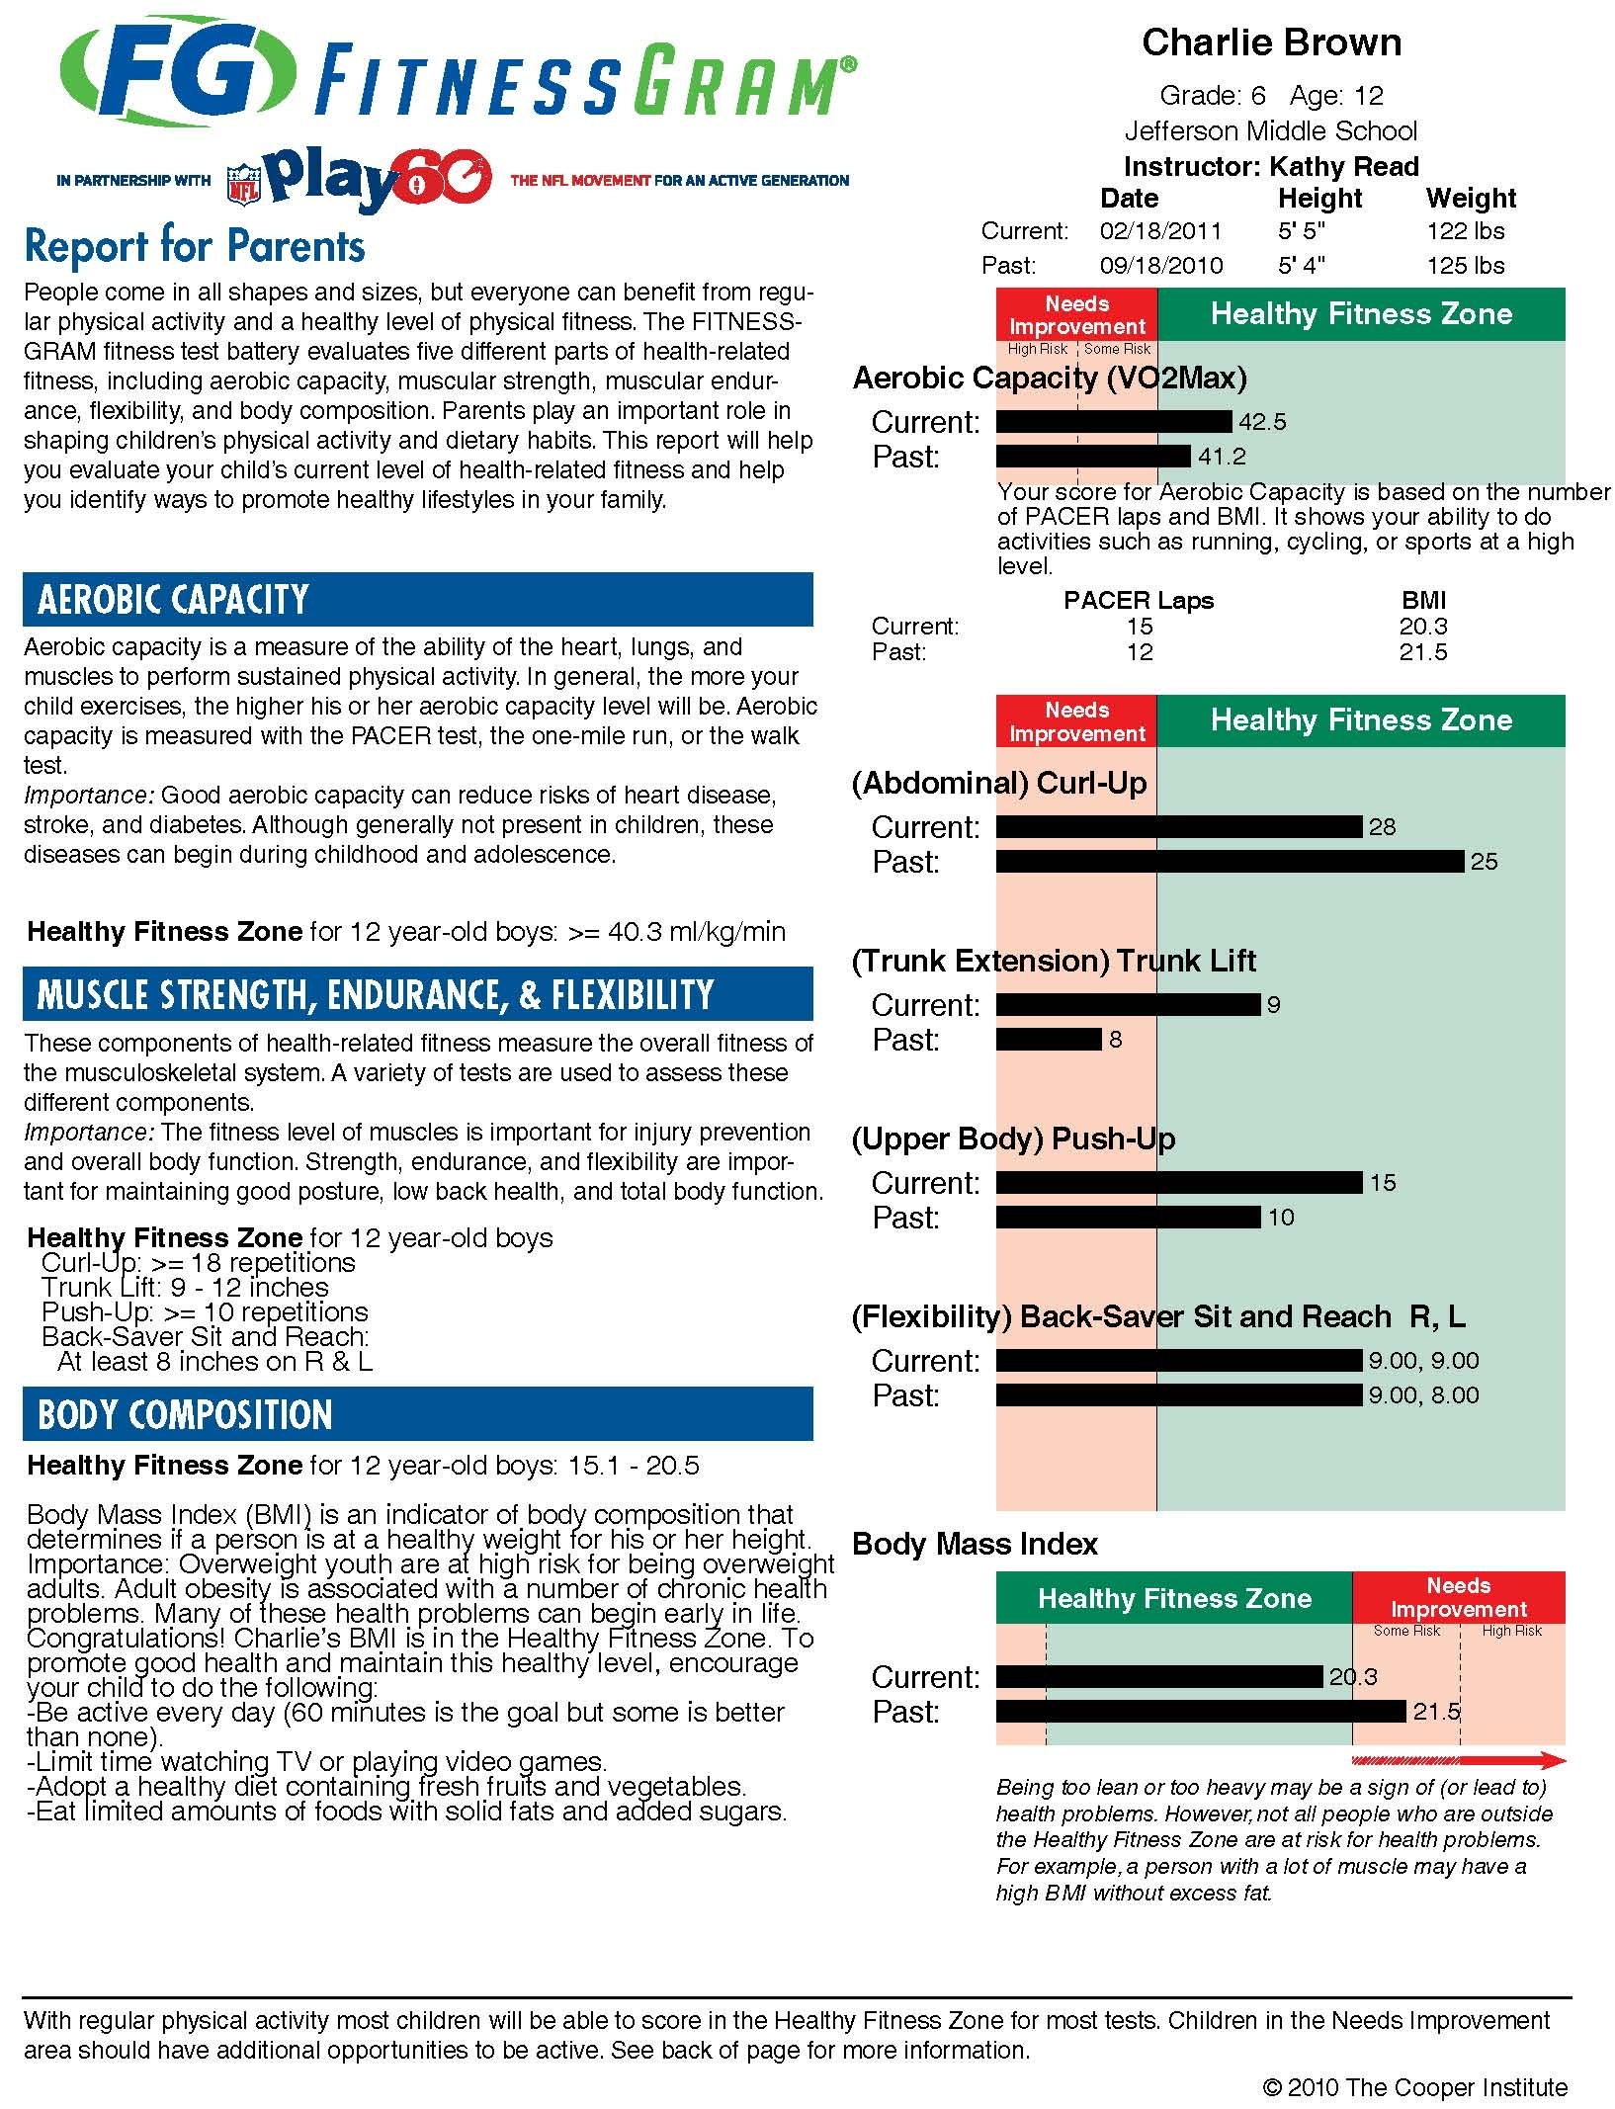
How can I help my child be more fit and active?

The philosophy of FITNESSGRAM spells HELP. We need your help to promote physical activity and fitness for your child. If parents value physical activity and encourage their children to be more active regularly, children are more likely to view physical activity as an important part of their daily lives. The following tips may help you encourage your child to be active:

- Provide a safe play area for your child to play and opportunities to be active.
- Provide equipment and supplies that allow your child to be active.
- Put limits on television time and video game usage (especially right after school).
- Participate in physical activity with your child.
- Help your child develop good physical skills so that he or she can feel important.

