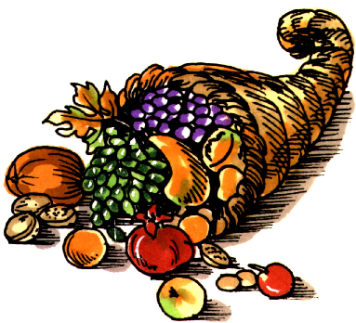


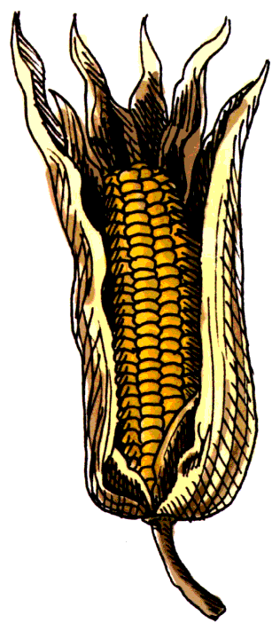
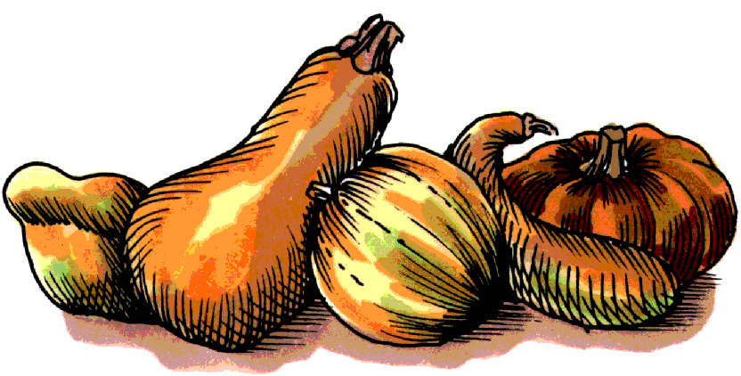

Volume (Click to change text) ( Name) School November 2011
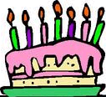
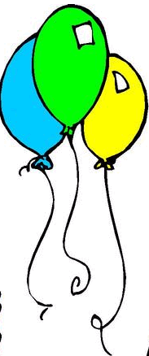
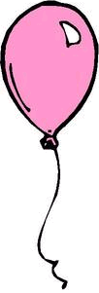

The more you read, the more things you will know. The more that you learn, the more places you’ll go. ~ Dr. Seuss

Literary Birthdays

Fran Manushkin November 2
Betty Bao Lord November 3

Ben Bova November 8
Nathaniel Benchley November 13

Robert Louis Stevenson November 13

William Steig November 14
Miska Miles November 14

Marion Dane Bauer November 20

Leo Politi November 21

Marc Brown November 25

Tomi Ungerer November 28

Madeleine L’Engle November 29

C.S Lewis November 29

Charles Schulz November 29
Margot Zemach November 30

Extra, extra, read

all about it!

Check out the 2011 Children’s Choices booklist from the International Reading Association and the Children’s Book Council. Some choices this year include:

Grades K-2
City Dog, Country Frog by Mo Willems

Grades 3-4
Bad Kitty vs. Uncle Murray: The Uproar at the Front Door by Nick Bruel

Grades 5-6
The Dreamer by Pam Munoz Ryan

Find the entire list here.

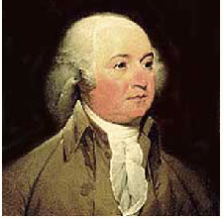
On November 1, 1800, John Adams arrived in the new federal city and moved into the President’s House. The next day, while sitting in a damp, unfinished room, John wrote a letter to his wife Abigail which included a blessing for the new house and its future inhabitants. This is what he wrote: "I pray heaven to bestow the best of belssings on this house and all that hereafter shall inhabit it. May none but honest and wise men ever rule under this roof." More than a century later, in the final year of World War II, President Franklin Delano Roosevelt had these words inscribed in gold just under the mantle on the fireplace in the State Dining Room. These words are still there today.

Never trust anyone who has not brought a book with them. ~ Lemony Snicket

Need help with homework or a project? Try GALILEO. Ask your teacher or Media Specialist for the password.

